Harmonic oscillator $F=-kx=m\frac{d^{2}x}{dt^{2}}$ solution: $x\left(t\right)=Asin\left(ωt\right)+Bcos\left(ωt\right) ω (ang freq)=\sqrt{\frac{k}{m}}$
Potential energy $V\left(x\right)=\frac{1}{2}kx^{2}=\frac{1}{2}mω^{2}x^{2} -\frac{h^{2}}{2m}φ''+\frac{1}{2}mω^{2}x^{2}φ=Eφ$
$$μ=\sqrt{\frac{mω}{h}}x K=\frac{2E}{hω} φ''=\left(μ^{2}-K\right)φ≅μ^{2}φ (assume large μ)$$
$$φ\left(μ\right)=Ae^{-\frac{μ^{2}}{2}}+Be^{\frac{μ^{2}}{2}} but B is not normalizable, so drop it φ\left(μ\right)=Ae^{-\frac{μ^{2}}{2}}$$
$$φ\left(μ\right)=Ae^{-\frac{μ^{2}}{2}}=h\left(μ\right)e^{-\frac{μ^{2}}{2}} φ'=\left(h^{'}-μh\right)e^{-\frac{μ^{2}}{2}} φ''=\left(h''-2μh'+\left(μ^{2}-1\right)h\right)e^{-\frac{μ^{2}}{2}}$$
$$φ^{''}=\left(μ^{2}-K\right)φ → h^{''}-2μh^{'}+\left(K-1\right)h=0 h\left(μ\right)=\sum_{j=0}^{∞}{a_{j}μ^{j}} a_{j+2}=\frac{2j+1-K}{\left(j+1\right)\left(j+2\right)}a_{j}$$
$$h is constant K-1=0 E_{0}=\frac{hω}{2} φ_{0}\left(μ\right)={\left(\frac{mω}{π\overline{h}}\right)}^{\frac{1}{4}}e^{-\frac{μ^{2}}{2}} ground state φ$$
$$φ_{n}\left(μ\right)={\left(\frac{mω}{π\overline{h}}\right)}^{\frac{1}{4}}\frac{1}{\sqrt{2^{n}}n!}H_{n}\left(μ\right)e^{-\frac{μ^{2}}{2}} E_{n}=hω\left(n+\frac{1}{2}\right) H_{n}\left(x\right)={\left(-1\right)}^{n}e^{x^{2}}\frac{d^{n}}{dx^{n}}e^{-x^{2}}$$
$$H_{0}=1 H_{1}=2x H_{3}=4x^{2}-2 H_{4}=16x^{4}-48x^{2}+12 H_{5}=32x^{5}-160x^{3}+120x$$

Formalism
Hilbert space, a type of vector space endowed with an inner product along with some other technical properties.
R², 2-D vector space, arrows in the plane. $v=(\begin{matrix}v_{x} \\ v_{y}\end{matrix})$

L²(R), the space of square-integrable complex functions of one real variable.
$$\int_{-∞}^{∞}{{\left|f\left(x\right)\right|}^{2}dx<∞}$$
This is the space of normalizable wave functions (with the zero function thrown in). this will be the Hilber space of the one-dimensional quantum system that extends to x$→±∞$ that we have studied so far, such as the free particle, finite square well, and simple harmonic oscillator (each system has a different Hilbert space in general). Note that the wave function itself is the component expression. Writing $φ(x)$ is like writing the column vector. In R² we have one real component for each of the two dimensions. L²(R) is an infinitely-dimensional space, though, so we need an infinite number of components. We get 1 complex component for each value of x. the “(x)” part of the function $φ(x)$ is like the x- or y-subscripts of the vector components.
$$A=A_{x}e_{x}+A_{y}e_{y}+A_{z}e_{z}=A_{x}\left(\begin{matrix}1 \\ 0 \\ 0\end{matrix}\right)+A_{y}\left(\begin{matrix}0 \\ 1 \\ 0\end{matrix}\right)+A_{z}\left(\begin{matrix}0 \\ 0 \\ 1\end{matrix}\right)=\left(\begin{matrix}A_{x} \\ A_{y} \\ A_{z}\end{matrix}\right) A=\sum_{n=1}^{N}{A_{n}e_{n}}=\left(\begin{matrix}A_{1} \\ … \\ A_{N}\end{matrix}\right)$$
Vectors in quantum mechanics are written as kets. A vector space is a set of vectors $|\left.α\right\rangle ,|\left.β\right\rangle ,\left.|γ\right\rangle$ together with a set of scalars a, b, c…, which are subject to two operations- vector addition and scalar multiplication.
$$|\left.α\right\rangle =φ_{α}\left(x\right)$$
Vector addition: $|\left.α\right\rangle + |\left.β\right\rangle = \left.|γ\right\rangle$  Commutative: $|\left.α\right\rangle + |\left.β\right\rangle =|\left.β\right\rangle +|\left.α\right\rangle$  Associative: $|\left.α\right\rangle +(|\left.β\right\rangle +|\left.γ\right\rangle )=(|\left.α\right\rangle +|\left.β\right\rangle )+|\left.γ\right\rangle$  Zero/null vector: $|\left.α\right\rangle + |\left.0\right\rangle = \left.|α\right\rangle$  Inverse vector $|\left.α\right\rangle +\left(- | \left.α\right\rangle \right)=0$ | Scalar multiplication a$|\left.α\right\rangle =\left.|γ\right\rangle$  Distributive: a($\left.|α\right\rangle +\left|\left.β\right\rangle \right)=a|\left.α\right\rangle +a\left.|β\right\rangle$  (a+b)$\left.|α\right\rangle =a\left.|α\right\rangle +b\left.|α\right\rangle$  Associative: a(b$\left.|α\right\rangle$)=(ab)$\left.|α\right\rangle$  Multiplication by the scalars 0 and 1  0$\left.|α\right\rangle =\left.|0\right\rangle$ 1$\left.|α\right\rangle =\left.|α\right\rangle$
A linear combination of the vectors $\left.|α\right\rangle , \left.|β\right\rangle , \left.|γ\right\rangle$… is an expression of the form $a\left.|α\right\rangle +b\left.|β\right\rangle +c\left.|γ\right\rangle +…$
A vector $\left.|τ\right\rangle$is said to be linearly independent of the set $\left.|α\right\rangle$, $\left.|β\right\rangle$, $\left.|γ\right\rangle$ if it cannot be written as a linear combination of them. In 3-D the unit vector k is independent of i and j.
A set of vectors is linearly independent of each other if each one is linearly independent of all the rest.
A collection of vectors is said to span the space if every vector can be written as a linear combination of the members of this set.
A set of linearly independent vectors that spans the space is called a basis. The number of vectors in any basis is called the dimension of the space.
$$\left.|e_{1}\right\rangle , \left.|e_{2}\right\rangle , \left.|e_{3}\right\rangle … \left.|e_{n}\right\rangle$$
Any given vector $\left.|a\right\rangle =a_{1}\left.|e_{1}\right\rangle +a_{2}\left.|e_{2}\right\rangle$ is uniquely represented by the ordered n-tuple of its components
$$\left.|α\right\rangle ↔\left(a_{1}, a_{2},…, a_{n}\right) |\left.α\right\rangle + |\left.β\right\rangle ↔\left(a_{1}+b_{1}, a_{2}+b_{2},…, a_{n}+b_{n}\right) c|\left.α\right\rangle ↔\left({ca}_{1}, {ca}_{2},…, {ca}_{n}\right)$$
$$\left.|0\right\rangle =↔\left(0, 0,…, 0\right) \left.|-α\right\rangle ↔\left({-a}_{1}, {-a}_{2},…, {-a}_{n}\right)$$
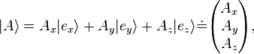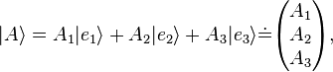
Dual space
Given a vector space, the dual space V is abstractly defined as the set of all linear functions from the vector space to the scalars. Vectors in the dual space in quantum mechanics are written as bras.
$$\left(φ+ϑ\right)\left(x\right)=φ\left(x\right)+ϑ\left(x\right) \left(aφ\right)\left(x\right)=a(φ\left(x\right))$$
$$\left\langle γ|\right.=\left\langle α|\right.+\left\langle β|\right. → \left\langle γ | φ\right\rangle =\left\langle α | φ\right\rangle +\left\langle β | φ\right\rangle$$
$$\left\langle γ|\right.=c\left\langle α|\right. → \left\langle γ | φ\right\rangle =c\left\langle α | φ\right\rangle$$
A bra eats a ket and spits out a number.

Inner product- a map from a pair of vectors to the scalars, written $\left\langle . | .\right\rangle$ where the two dots indicate the two slots that are to be filled with kets.
$$\left\langle α | β\right\rangle ={\left\langle β | α\right\rangle }^{*} \left\langle α | α\right\rangle ≥0 I\left(\left.|α\right\rangle ,\left.|β\right\rangle \right)= I{\left(\left.|β\right\rangle ,\left.|α\right\rangle \right)}^{*}$$
Linear in the second slot
$$\left\langle α|\right.\left(\left.b|β\right\rangle +\left.c|γ\right\rangle \right)=b\left\langle α | φ\right\rangle +c\left\langle α | γ\right\rangle I\left(\left.|α\right\rangle ,\left.b|β\right\rangle +\left.c|γ\right\rangle \right)=b I\left(\left.|α\right\rangle ,\left.|β\right\rangle \right)+cI\left(\left.|α\right\rangle ,\left.|γ\right\rangle \right)$$
Anti-linear in the first slot
$$I\left(a\left.|α\right\rangle \left.+b|β\right\rangle ,\left.γ\right\rangle \right)=a^{*} I\left(\left.|α\right\rangle ,\left.|γ\right\rangle \right)+b^{*} I\left(\left.|β\right\rangle ,\left.|γ\right\rangle \right)$$
$$\left\langle α|\right.=I\left(\left.|α\right\rangle , ∙\right)$$
The bra associated with the ket $\left.|φ\right\rangle =a\left.|α\right\rangle +b\left.|β\right\rangle is \left\langle φ|\right.=a^{*}\left\langle α|\right.+b^{*}\left\langle β|\right.$
$$\left\|α\right\|=\sqrt{\left\langle α | α\right\rangle }$$
Normalized, $\left\|α\right\|=1 \left\langle α | α\right\rangle =1$
Orthogonal $\left\langle α | β\right\rangle =0$
$${\left|\left\langle α | β\right\rangle \right|}^{2}=\left\langle α | β\right\rangle \left\langle β | α\right\rangle ≤\left\langle α | α\right\rangle \left\langle β | β\right\rangle$$
Orthonormal basis $\left\{\left.|e_{i}\right\rangle \right\}$ on an inner product space is a basis such that I($\left.|e_{i}\right\rangle , \left.|e_{j}\right\rangle$)=$δ_{ij}$
$$\left\langle e_{i}|\right.=I\left(\left.|e_{i}\right\rangle , ∙\right)$$
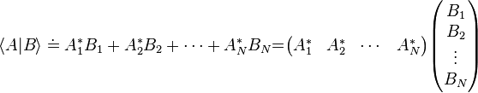
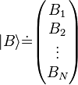 $A_{i}=\left\langle e_{i} | A\right\rangle$
A vector space equipped with an inner product on that space is called an inner product space. A Hilbert space is a complete inner product space.

The set of normalizable functions on the interval [0,a] that vanish at the endpoints is the vector space for the infinite square well.
The set of normalizable functions on the interval [$-∞$,$∞$] is the vector space for the free particle, the finite square well, and the simple harmonic oscaillator.

Operators on a Hilbert space are linear maps from vectors to vectors. Operators act on kets from the left and act on bras on from the right.
$$\hat{Q}\left(a\left.|α\right\rangle +b\left.|β\right\rangle \right)=a\hat{Q}\left.|α\right\rangle +b\hat{Q}\left.|β\right\rangle$$
$$(\left\langle φ | \hat{Q}\right\rangle )\left.|α\right\rangle =\left\langle φ | (\hat{Q}\right\rangle |\left.α\right\rangle )$$
The matrix element of an operator is written $\left\langle α | \hat{Q} | β\right\rangle$ and can be considered the bra $\left\langle α\right.|$ acting on the ket $\hat{Q}\left.|β\right\rangle$ or the bra $\left\langle α\right.|Q$ acting on the ket $\left.|β\right\rangle$. The expectation value on the state is written $〈\hat{Q}〉=\left\langle φ | \hat{Q} | φ\right\rangle$

Commutator $\left[\hat{Q},\hat{P}\right]=\hat{Q}\hat{P}-\hat{P}\hat{Q}$ difference of the product of the operators in either order
Outer product , an operator. The action of this operator on a ket is the ket $|\left.α\right\rangle$ multiplied by the scalar the results from the bra $\left\langle β|\right.$ acting on a ket.
Not all operators can be written as outer products, but all operators can be written as sums of outer products.
Given a basis $\left\{\left.|e_{i}\right\rangle \right\}$, the sum of all of the “diagonal” outer products $\left.|e_{i}\right\rangle \left\langle e_{i}|\right.$ (outer products of a basis ket with itself, also called a basis projection operator) gives the identity.
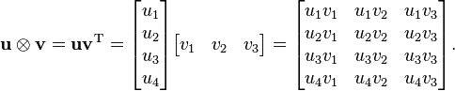
The inner product is the trace of the outer product.
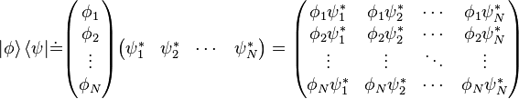
.
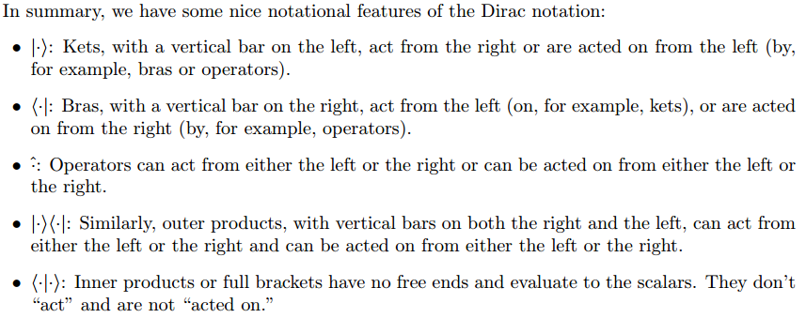
The components of v as v^{i}. Taking the transpose flips upper and lower indices.
$${\left(v^{T}\right)}_{i}=v^{i} {\left(A^{T}\right)}_{j}^{i}=A_{i}^{j}$$
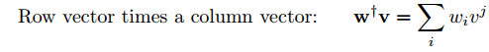 | the matrix form of the inner product
 | the matrix form of the outer product
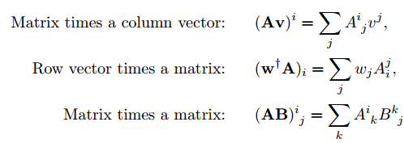
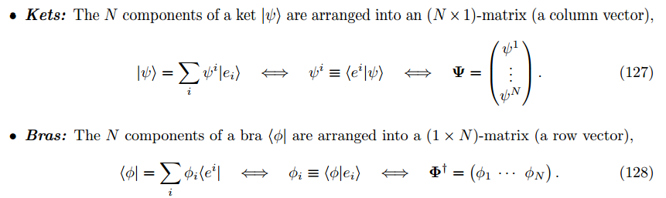
The action of a bra on a ket is thus the matrix multiplication (1 X N) . (N X 1) = 1 X 1 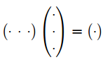
Given a ket, the components of the dual bra are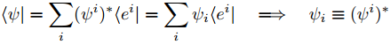
Thus the matrix representation for $\left\langle φ|\right.$ is the Hermitian conjugate of the matrix representation of the ket $\left.|φ\right\rangle$
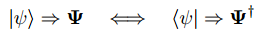
Hermitian conjugate- the complex conjugate of the transpose
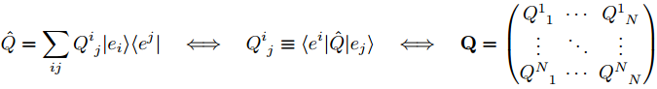
The N² components of an operator Q are arranged into an N X N matrix.
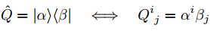
The outer product is thus represented by the matrix multiplication of (N X 1). (1 X 1) = N X N.
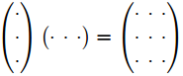

An operator Q has eigenvalue λ if there exists some nonzero vector $\left.|q\right\rangle$ such that
$$Q\left.|q\right\rangle =λ\left.|q\right\rangle$$
Any ket $\left.|q\right\rangle$ for a given λ is called an eigenvector or eigenket belonging to the eigenvalue λ. The set of all eigenvalues for a given operator is called the operator’s spectrum. For a given eigenvalue the subset of the Hilbert space consisting of all eigenvectors belonging to that eigenvalue is called the eigenspace for that eigenvalue. Eigenspaces are vector subspaces of the Hilbert space.
A given eigenvalue is called non-degenerate if the eigenspace corresponding to the eigenvalue is one-dimensional. A given eigenvalue is called degenerate if the eigeenspace corresponding to that eigenvalue is more than one-dimensional.
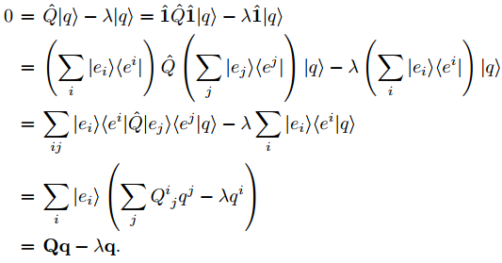
Regardless of our choice of orthonormal basis, if λ is an eigenvalue of the matrix Q then it is an eigenvalue of the operator Q. Finding the spectrum thus becomes finding the spectrum of a matrix.

The adjoint of an operator Q is an operator Q⁺ such that for all $\left.|α\right\rangle , \left.|β\right\rangle$
$$I\left({\hat{Q}}^{+}\left.|α\right\rangle ,\left.|β\right\rangle \right)=I\left(\left.|α\right\rangle ,\hat{Q}\left.|β\right\rangle \right) I\left(\left.\hat{Q}|α\right\rangle ,\left.|β\right\rangle \right)=I\left(\left.|α\right\rangle ,{\hat{Q}}^{+}\left.|β\right\rangle \right)$$
- ${({\hat{Q}}^{+})}^{+}=\hat{Q}$ or the adjoint of the adjoint is the original operator
- Operators satisfying ${\hat{Q}}^{+}=\hat{Q}$ are called self-adjoint or Hermitian operators.
- Operators satisfying ${\hat{Q}}^{+}=-\hat{Q}$ are called anti-self-adjoint or anti-Hermitian operators.
- Any operator can be broken up into a sum of a Hermtian part an an anti-Hermitian part.
- Given a Hermitian operator $\hat{Q}$ the operator i$\hat{Q}$ is anti-Hermitian and vice versa.
- Operators satisfying ${\hat{Q}}^{+}={\hat{Q}}^{-1}$ or $\hat{Q}{\hat{Q}}^{+}={\hat{Q}}^{+}\hat{Q}=1$ are called unitary operators

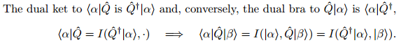
The matrix representation of the adjoint operator is the Hermitian conjugate of the matrix representation of the operator. 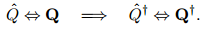

The eigenvalues of Q are real. Let λ be an eigenvalue of Q and let q be an eigenvector belonging to λ.
$$\left\langle q | Q | q\right\rangle =I\left(\left.|q\right\rangle , Q\left.|q\right\rangle \right)=I\left(\left.|q\right\rangle ,\left.λ|q\right\rangle \right)=λ I\left(\left.|q\right\rangle ,\left.|q\right\rangle \right)=λ \left\langle q | q\right\rangle =I\left(Q^{+}\left.|q\right\rangle ,\left.|q\right\rangle \right)=I\left(Q\left.|q\right\rangle , \left.|q\right\rangle \right)=I\left(λ\left.|q\right\rangle , \left.|q\right\rangle \right)=λ^{*}I\left(\left.|q\right\rangle , \left.|q\right\rangle \right)=λ^{*}\left\langle q | q\right\rangle$$
$λ=λ^{*}$ the eigenvalue is real.

Eigenvectors belonging to distinct eigenvalues are orthogonal. Let$λ_{1}$and$λ_{2}$ be distinct eigenvalues ($λ_{1}≠λ_{2})$ and let q1 and q2 be eigenvectors belonging to$λ_{1}$and$λ_{2}$ respectively. Note that we have already shown that the eigenvalues must all be real.
$$\left\langle q_{1} | Q | q_{2}\right\rangle =I\left(\left.|q_{1}\right\rangle , Q\left.|q_{2}\right\rangle \right)=I\left(\left.|q_{1} \right\rangle ,\left.λ_{2}|q_{2}\right\rangle \right)=λ_{2} I\left(\left.|q_{1}\right\rangle ,\left.|q_{2}\right\rangle \right)=λ_{2} \left\langle q_{1} | q_{2}\right\rangle =I\left(Q^{+}\left.|q_{1}\right\rangle ,\left.|q_{2}\right\rangle \right)=I\left(Q\left.|q_{1}\right\rangle , \left.|q_{2}\right\rangle \right)=I\left(λ_{1}\left.|q_{1}\right\rangle , \left.|q_{2}\right\rangle \right)=λ_{1}^{*}I\left(\left.|q_{1}\right\rangle , \left.|q_{2}\right\rangle \right)=λ_{1}\left\langle q_{1} | q_{2}\right\rangle$$
$$λ_{1}≠λ_{2}, \left\langle q_{1} | q_{2}\right\rangle =0$$
The eigenvalues of a Hermitian operator span the Hilbert space. If an operator has a discrete spectrum of eigenvalues this means that we can form an orthonormal basis from the eigenvectors of a Hermitian operator. Such a basis is called an eigenbasis for the operator.

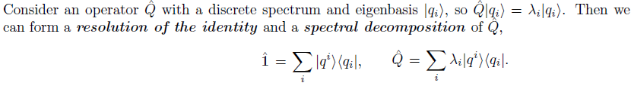
The adjoint of an operator Q is an operator written as Q⁺. We can extend this notation to other objects. The adjoint of a bra is the dual ket, ${\left\langle α|\right.}^{+}=\left.|α\right\rangle$; the adjoint of the ket is the dual bra, ${\left.|α\right\rangle }^{+}=\left\langle α|\right.$
The adjoint of a scalar is its complex conjugate.
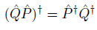
Let Q be an operator. With respect to a basis the matrix elements of the adjoint are.

The position and momentum operators x and p are Hermitian operators but have a continuous spectrum of eigenvalues. We define the continuous sets of eigenvectors: , where x and p can be any real number. The eigenvalues are all real. The eigenvectors belonging to different eigenvalues are orthogonal, and the set of eigenvectors are complete in that they span the Hilbert space. However, we can no longer form an orthonormal basis in the discrete sense. Instead, we have to define orthonormality in the continuous sense.
Resolution of identity
$$\hat{1}=\int_{-∞}^{∞}{dx \left.|x\right\rangle \left\langle x|\right.}=\int_{-∞}^{∞}{dp \left.|p\right\rangle \left\langle p|\right.}$$
Position and momentum space wavefunction are just the inner products with the basis vectors
Comparing the two previous equation with the momentum eigenfunctions
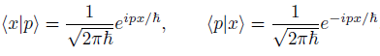
Normalization
Fourier transform

Changing basis
Let be two different orthonormal bases for a given Hilbert space. We define the change-of-basis operator U as the operator that maps the new basis kets to the old basis kets. 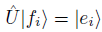
Since the e-basis and f-basis are both orthonormal and the change-of-basis matrix is necessarily invertible, with . In the f-basis the matrix representation of U is U with components given by. 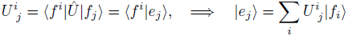
The components of U are the expansion coefficients of the e-basis kets in the f-basis. The matrix U is also called the transformation matrix.
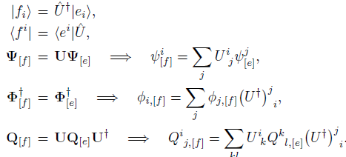
$$U_{[e]}=U_{[f]}$$
If a matrix is Hermitian or Unitary in one basis, it is Hermitian or Unitary in the other.
The trace and determinant of a matrix are independent of the orthonormal basis chosen.

Postulates
- A given quantum system is described by a Hilbert space. The state of a quantum system is given by a normalized vector in the Hilbert space of the system.
- Physically measurable quantities (observable) quantities of a system are represented by Hermitian operators on the Hilbert space for the system.
A projection operator is an operator which picks out certain components of a vector (such as projecting an ordinary vector in three dimensions onto the x-axis or the y-axis or the xy plane). One of the main properties of a projection operator is that it is idempotent, applying the projection twice is the same as applying the projection once.
The projection operator onto one-dimensional space spanned by the normalized ket $\left.|a\right\rangle$ is $P_{a}=\left.|a\right\rangle \left\langle a|\right.$. Consider an operator Q and a potentially degenerate eigenvalue$λ$. Let $\left.|a_{i}\right\rangle$ be an orthonormal basis for the$λ$-eigenspace. That is $Q\left.|a_{n}\right\rangle =λ\left.|a_{n}\right\rangle$. Then the projection operator onto the eigenspace is
$$P_{λ}=\sum_{n}{\left.|a_{n}\right\rangle \left\langle a_{n}|\right.}$$
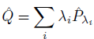
- Let Q be an Hermitian operator associated with a measurable quantity, let $λ_{i}$ be the spectrum of Q, and, for each $λ_{i}$ let $P_{λ_{i}}$ be the projection onto the$λ_{i}$-eigenspace.
  - The only possible results of the measurement are the eigenvalues$λ_{i}$ of Q.
  - The probability of getting the result$λ_{i}$, when making the measurement on a state $\left.|φ\right\rangle$ is given by: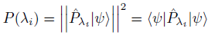
  - If the eigenvalue $λ_{i}$ is non-degenerate and $\left.|q_{i}\right\rangle$ is the normalized eigenvector belonging to the eigenvalue $λ$ then the above equation reduces to 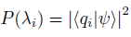
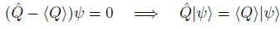
Possible results- 1, 2
The probability of a measurement resulting in the value 1. 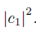
The probability of a measurement resulting in the value 2. 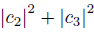

- The dynamics of a quantum system are given by the Hamiltonian operator for the system H via:
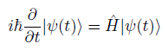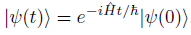
- Immediately after the measurement the state undergoes collapse. The new state is the normalized projection onto the relevant eigenspace. That is, consider a measurement of eigenvalue$λ$ at time t = T. If the state just before the measurement is . Then the state just after the measurement is 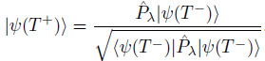
If the eigenvalue is non-degenerate then the state just after measurement, up to an arbitrary phase, is

