Physics Final Review Sheet
Charges are not created, but separated.

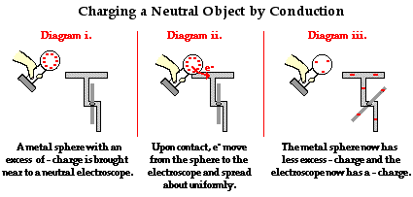
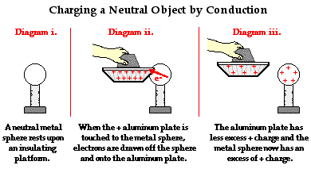
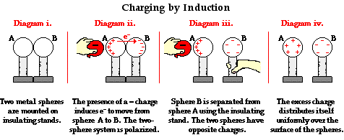
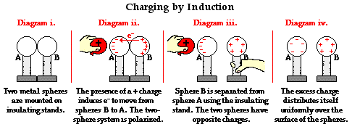
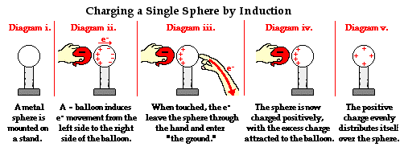
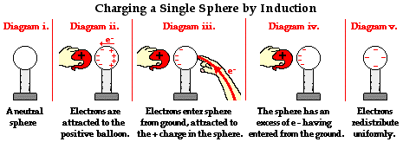
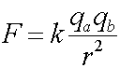 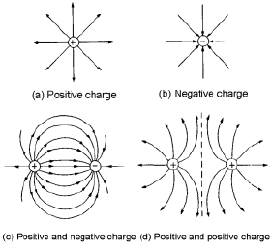 E = F on q / q
Potential difference, voltage = W on q / q = Ed
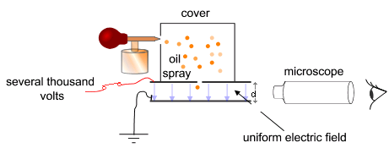

Definition | Expression | Unit
Voltage is energy per coulomb. | V=E/q, V=IR | J/C or V
Current is coulomb per second. | I=q/t, I=V/R | C/s or A
Resistance is volt per ampere | R=V/I | Ω
Power is energy per second. | P=E/t | J/s or W
Derived formulas
P= I^2 * R = V^2 / R
E= Pt = I^2 * R * t = V^2 / R * t

kWh is a unit for energy, not power, and it is equivalent to 3.6*10^6 J.

Circuits
Series | Parallel
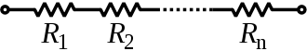 | 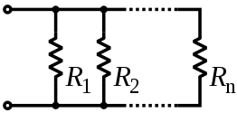
 | 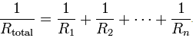
Vtotal = V1 + V2 + V3… | V is the same throughout.
I is the same throughout. | I total = I1 + I2 + I3 ...
One bulb goes out, everything goes out. | One bulb goes out, no effect.

Ammeter should be placed in series with the resistor because it has little resistance.
Voltmeter should be placed in parallel with the resistor because it has large resistance.

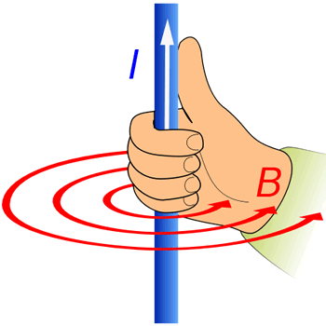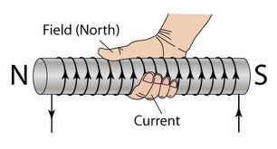
First Right Hand Rule Second Right Hand Rule
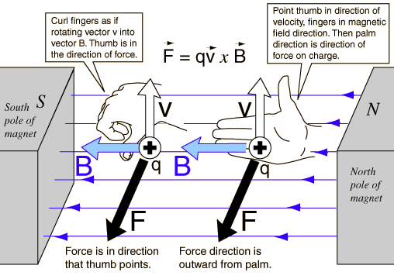 F=ILB
EMF = BLv sinθ
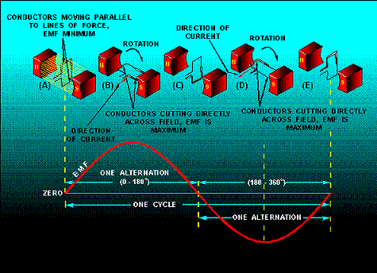

I_{eff} = I_{max} / sqrt(2)
I_{eff} ~ 0.707 * I_{max}
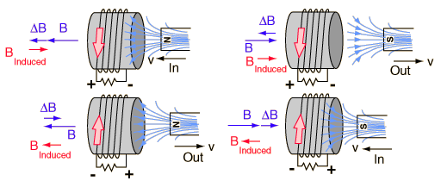
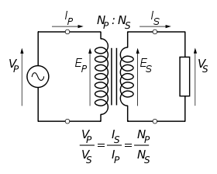
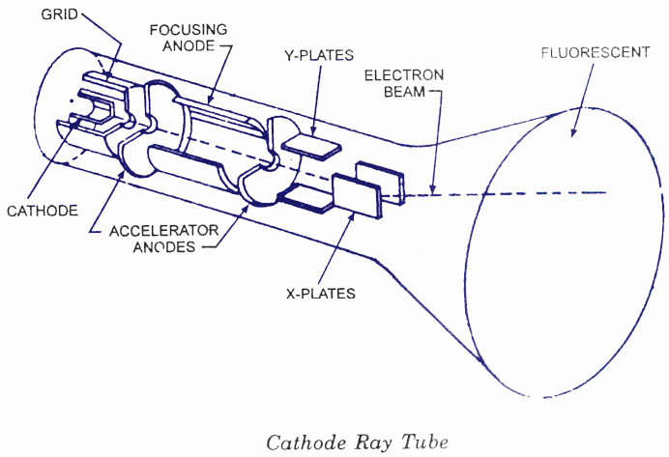 | q v  m = Br

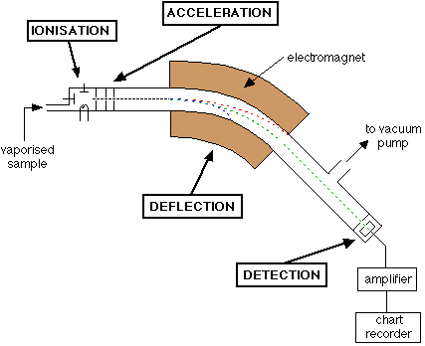 | q 2V  m = (Br)^2  Mass spectrometer
Stage 1: Ionization
The atom is ionized by knocking one or more electrons off to give a positive ion. This is true even for things which you would normally expect to form negative ions (chlorine, for example) or never form ions at all (argon, for example). Mass spectrometers always work with positive ions.
Stage 2: Acceleration
The ions are accelerated so that they all have the same kinetic energy.
Stage 3: Deflection
The ions are then deflected by a magnetic field according to their masses. The lighter they are, the more they are deflected.
The amount of deflection also depends on the number of positive charges on the ion - in other words, on how many electrons were knocked off in the first stage. The more the ion is charged, the more it gets deflected.
Stage 4: Detection
The beam of ions passing through the machine is detected electrically.
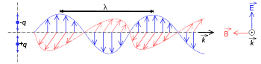
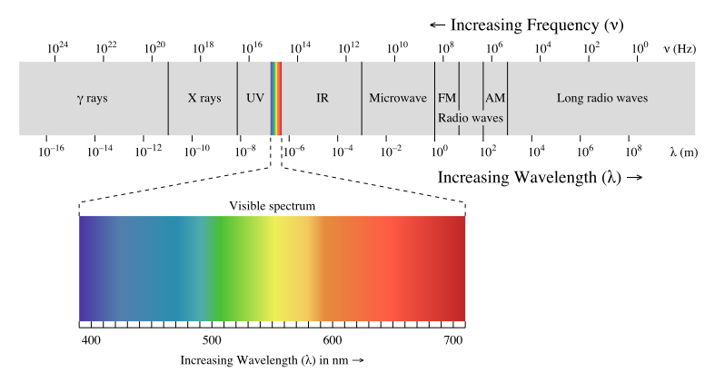
On an emission spectrum
P ~ T^4
Peak f ~ T
1/λ ~ T

E=nhf, thus energy is quantized

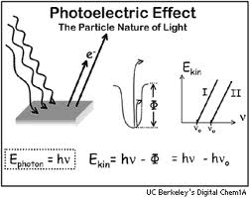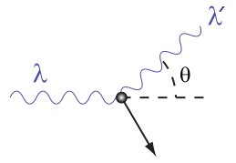
Compton Effect p=h/v

De Broglie found out that particles have wave nature and λ = h/mv

