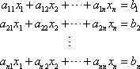 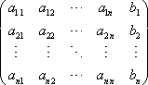 augmented matrix
3 elementary row operations
Interchange two rows. This is exactly what it says. We will interchange row i with row j.
Multiply row i by a constant, c. This means that every entry in row i will get multiplied by the constant c.
Add a multiply of row i to row j. In our heads we will multiply row i by an appropriate constant and then add the results to row j and put the new row back into row j leaving row i in the matrix unchanged.

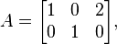  then the row vectors are r₁ = (1, 0, 2) and r₂ = (0, 1, 0). A linear combination of r₁ and r₂ is any vector of the form | If 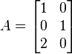, then the column vectors are v₁ = (1, 0, 2)^{T} and v₂ = (0, 1, 0)^{T}.  A linear combination of v₁ and v₂ is any vector of the form  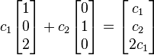

Let A be a m-by-n matrix. Then
- rank(A) = dim(row(A)) = dim(col(A)),
- rank(A) = number of pivots in any echelon form of A,
- rank(A) = the maximum number of linearly independent rows or columns of A.

Let T:Rn→Rm be a linear transformation. The following are equivalent:
One to one | Onto
- T is one-to-one.  - T(x)=0 has only the trivial solution x=0.  - If A is the standard matrix of T, then the columns of A are linearly independent.  - ker(A)={0}.  - nullity(A)=0.  - rank(A)=n. | - T is onto.  - The equation T(x)=b has solutions for every b∈Rm.  - If A is the standard matrix of T, then the columns of A span Rm. That is: every b∈Rm is a linear combination of the columns of A.  - Im(A)=Rm.  - rank(A)=m.  - nullity(A)=n−m.
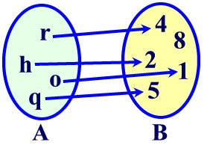 | 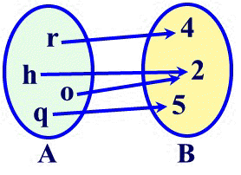

If A is an n x n matrix then is an n^{th} degree polynomial. This polynomial is called the characteristic polynomial.

(W⊥)⊥ = W
(Row A)⊥ = Null A
(Col A)⊥ = Null A^{T}

Least square method
Predicted y-value
k₀ + k₁x₁ = y₁
k₀ + k₁x₂ = y₂
.
.
k₀ + k₁x_{n} = y_{n}

Xk = y where X = [1 x₁ k = [ k₀ y = [y₁
1 x₂ k₁] y₂
. .
. .
1 x_{n}] y_{n}]

X^{T}Xk = X^{T}y
Compute X^{T}X and X^{T}y, then solve for k.

Gram Schmidt
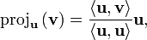
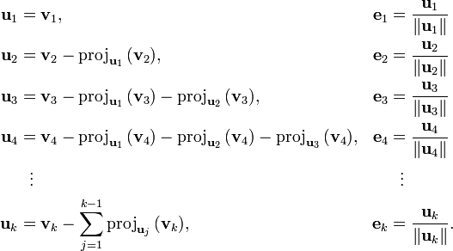

Inner product space  with equality only for | Cauchy-Schwarz inequality
Diagonalizable matrix  A square matrix A is called diagonalizable if it is similar to a diagonal matrix, i.e., if there exists an invertible matrix P such that P⁻¹AP is a diagonal matrix.  An n×n matrix A is diagonalizable if and only if the sum of the dimensions of its eigenspaces is equal to n  The diagonal entries of this matrix are the eigenvalues of A. | Symmetric matrix  For every symmetric real matrix A there exists a real orthogonal matrix Q such that D = Q^{T}AQ is a diagonal matrix.  Every real symmetric matrix has real eigenvalues.
Jordan normal form
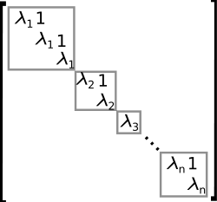
Any non-diagonal entries that are non-zero must be equal to 1, be immediately above the main diagonal and have identical diagonal entries to the left and below them.

Generalized eigenvector
A generalized eigenvector of A is a nonzero vector v, which is associated with λ having algebraic multiplicity k ≥1, satisfying The set spanned by all generalized eigenvectors for a given λ, form the generalized eigenspace for λ.
Solve for where v₁ is the first eigenvector, and v₂ is the generalized eigenvector, λ is the eigenvalue.
Or solve for where v is the generalized eigenvector, and k is any integer.

Real roots Complex roots Repeated roots
r₁ and r₂ r₁ = r₂ = r

Wronskian and fundamental set of solutions
If 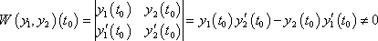
Then , the 2 solutions are called a fundamental set of solutions.

Method of undetermined coefficients
To find a particular solution to the differential equation ay’’ + by’ + cy = Ct^{m}e^{rt} use the form
$$y_{p}\left(t\right)=t^{s}\left(A_{m}t_{m}+…+A_{1}t+A_{0}\right)e^{rt}$$
  - s = 0 if r is not a root of the associated auxiliary equation
  - s = 1 if r is a simple root of the associated auxiliary equation
  - s = 2 if r is a double root of the associated auxiliary equation

To find a particular solution to the differential equation ay’’ + by’ + cy = Ct^{m}e^{αt}cosβt or Ct^{m}e^{αt}sinβt use the form
$$y_{p}\left(t\right)=t^{s}\left(A_{m}t_{m}+…+A_{1}t+A_{0}\right)e^{αt}cosβt+ t^{s}\left(B_{m}t_{m}+…+B_{1}t+B_{0}\right)e^{αt}sinβt$$
  - s = 0 if α+βi is not a root of the associated auxiliary equation
  - s = 1 if α+βi is a root of the associated auxiliary equation

g(t) | y_{p}(t) guess
n^{th} degree polynomial

Variation of parameters
ay’’+by’+c = g(t)
y_{p}(t) = v₁(t)y₁(t) + v₂(t)y₂(t)

y₁v₁’ + y₂v₂’ = 0
y₁’v₁’ + y₂’v₂’ = g/a
$$v1\left(t\right)= \int{\frac{-g\left(t\right)y_{2}(t)}{a[y_{1}\left(t\right)y_{2}^{'}\left(t\right)-y_{1}^{'}\left(t\right)y_{2}\left(t\right)]}dt} v2\left(t\right)= \int{\frac{g\left(t\right)y_{1}(t)}{a[y_{1}\left(t\right)y_{2}^{'}\left(t\right)-y_{1}^{'}\left(t\right)y_{2}\left(t\right)]}dt}$$

Fourier sine series
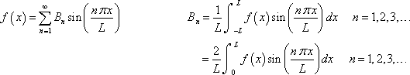
Fourier cosine series
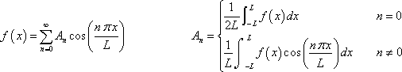

Heat equation
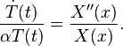 both sides are equal to some constant value −λ

λ < 0 | λ = 0 | λ > 0
 | X(x) = Bx + C
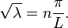

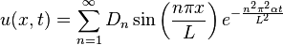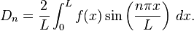

$$\frac{∂u}{∂t}=c\frac{∂^{2}u}{∂x^{2}} 0<x<π , t>0$$
$$u\left(0,t\right)=u\left(π,t\right)=0 , t>0$$
$$u\left(x,0\right)=f\left(x\right)= \sum_{n=1}^{∞}{c_{n}\sin{\frac{nπx}{L}}}$$
$$u\left(x,t\right)= \sum_{n=1}^{∞}{c_{n}e^{\frac{-cn^{2}π^{2}}{L^{2}}}\sin{\frac{nπx}{L}}}$$

Wave equation
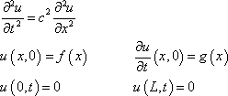

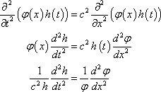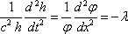

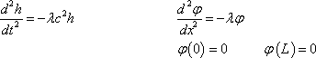

Solution:
$$u\left(x,t\right)=\sum_{n=1}^{∞}{{[a}_{n}\cos{\frac{nπc}{L}t+}}b_{n}sin\frac{nπc}{L}t]\sin{\frac{nπx}{L}}$$
Where a_{n}’s and b_{n}’s are determined from the Fourier sine series
$$f\left(x\right)= \sum_{n=1}^{∞}{a_{n}\sin{\frac{nπx}{L}}} g\left(x\right)= \sum_{n=1}^{∞}{b_{n}\frac{nπc}{L}sin{\frac{nπx}{L}}}$$

d’Alambert solution
$$\frac{∂^{2}u}{∂t^{2}}= c^{2}\frac{∂^{2}u}{∂x^{2}} -∞<x<∞ , t>0$$
$$u\left(x,0\right)=f\left(x\right) -∞<x<∞ ,$$
$$\frac{∂u}{∂t}\left(x,0\right)=g\left(x\right) -∞<x<∞ ,$$
$$u\left(x,t\right)= \frac{1}{2}\left[f\left(x+ct\right)+f\left(x-ct\right)\right]+ \frac{1}{2c}\int_{x-ct}^{x+ct}{g\left(s\right)ds}$$

Laplace’s equation
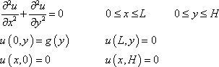

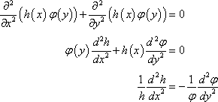
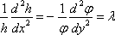

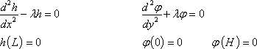

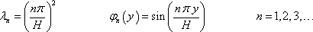

$$u_{n}\left(x,y\right)=E_{n}\cos\left(\frac{nπx}{L}\right)sinh⁡(\frac{nπ\left(y-H\right)}{L})$$
$$u\left(x,y\right)=E_{0}\left(y-b\right)+\sum_{n=1}^{∞}{E_{n}cos\left(\frac{nπx}{L}\right)\sinh\left(\frac{nπ\left(y-H\right)}{L}\right)}$$
$$E_{0}=\frac{1}{-LH}\int_{0}^{a}{f\left(x\right)dx}$$
$$E_{n}=\frac{2}{Lsinh⁡(\frac{-nπH}{L})}\int_{0}^{a}{f\left(x\right)cos⁡(\frac{nπx}{L})dx}$$

