Eigenvalue $\det\left(λI-A\right)=0 λ=\frac{a_{11}+a_{22}±\sqrt{{\left(a_{11}+a_{22}\right)}^{2}-4\left(a_{11}a_{22}-a_{12}a_{21}\right)}}{2}$ $L\left[f\left(t\right)\right]=F\left(s\right)=\int_{0}^{∞}{f\left(t\right)e^{-st}dt}$
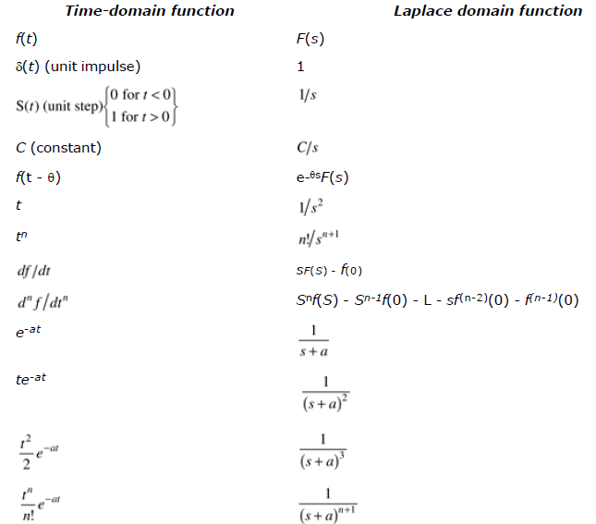 | 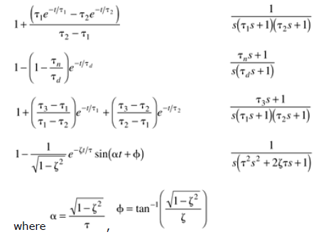
$$final value theorem: \lim_{t→∞}{f\left(t\right)}=\lim_{s→0}\left[sF\left(s\right)\right] initial value theorem: \lim_{t→0}{f\left(t\right)}=\lim_{s→∞}\left[sF\left(s\right)\right]$$
2nd order systems
$$a_{0}\frac{d^{2}y}{dt^{2}}+a_{1}\frac{dy}{dt}+a_{0}y=b_{0}u\left(t\right) τ^{2}\frac{d^{2}y}{dt^{2}}+2τφ\frac{dy}{dt}+y=ku\left(t\right) τ^{2}=\frac{a_{2}}{a_{0}} 2τφ=\frac{a_{1}}{a_{0}} k=\frac{b_{0}}{a_{0}}$$
$$τ^{2}\left[s^{2}y\left(s\right)+sy\left(0\right)+\dot{y}\left(0\right)\right]+2τφ\left[sy\left(s\right)-y\left(0\right)\right]+y\left(s\right)=ku\left(s\right) y\left(s\right)=\frac{k}{τ^{2}s^{2}+2τφs+1}u\left(s\right)$$
$$two poles: p_{1}=-\frac{φ}{τ}+\frac{\sqrt{φ^{2}-1}}{τ} p_{2}=-\frac{φ}{τ}-\frac{\sqrt{φ^{2}-1}}{τ}$$
Damping factor | Pole location | Characteristic behavior | Step response
$$φ>1$$ | Two real, distinct roots | Overdamped | $$τ^{2}s^{2}+2τφs+1=\left(τ_{1}s+1\right)\left(τ_{2}s+1\right)$$  $$τ_{1}=\frac{τ}{φ-\sqrt{φ^{2}-1}} τ_{2}=\frac{τ}{φ+\sqrt{φ^{2}-1}}$$  $$y\left(t\right)=k∆u\left[\frac{1+τ_{1}e^{-\frac{t}{τ_{1}}}-τ_{2}e^{-\frac{t}{τ_{2}}}}{τ_{2}-τ_{1}}\right]$$
$$φ=1$$ | Two real, equal roots | Critically damped | $$y\left(t\right)=k∆u\left[1-\left(1+\frac{t}{τ}\right)e^{-\frac{t}{τ}}\right]$$
$$φ<1$$ | Two complex conjugate roots | Underdamped | $$y\left(t\right)=k∆u\left[1-\frac{1}{\sqrt{1-φ^{2}}}e^{-\frac{φt}{τ}}\sin{αt+β}\right]$$  $$α=\frac{\sqrt{1-φ^{2}}}{τ} β=\tan^{-1}{(\frac{\sqrt{1-φ^{2}}}{φ})}$$
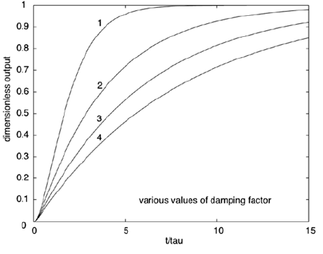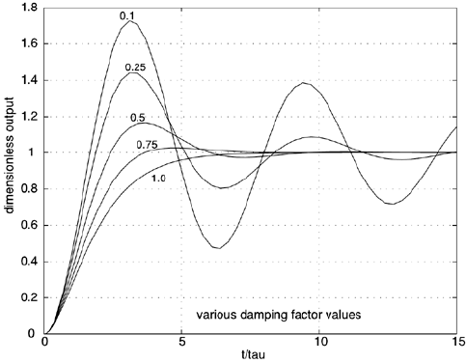
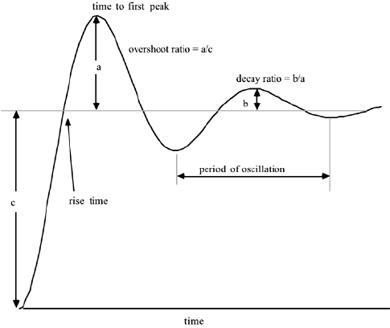 | Process gain, $k_{p}=\frac{∆y}{∆u}=\frac{y_{ss}-y_{0} }{∆u}=c$  To calculate $τ,$ see where the first peak occurs, and divide that by $\frac{t}{τ}$.  $$decay ratio=\frac{b}{a}$$  $$overshoot ratio=\frac{a}{c}=\frac{a}{∆y}$$
$$g\left(s\right)=\frac{k_{p}\left(τ_{n}s+1\right)}{\left(τ_{1}s+1\right)(τ_{2}s+1)}=\frac{k_{pz}\left(s-z_{1}\right)}{(s-p_{1})(s-p_{2})} k_{pz}=\frac{kτ_{n}}{τ_{1}τ_{2}} p_{1}=-\frac{1}{τ_{1}} p_{2}=-\frac{1}{τ_{2}} z_{1}=-\frac{1}{τ+n }$$
$$y\left(t\right)=k_{p}∆u\left[1+\left(\frac{τ_{n}-τ_{1}}{τ_{1}-τ_{2}}\right)e^{-\frac{t}{τ_{1}}}+\left(\frac{τ_{n}-τ_{2}}{τ_{1}-τ_{2}}\right)e^{-\frac{t}{τ_{2}}}\right]$$
Lead-lag behavior $g\left(s\right)=k_{p}\frac{\left(τ_{n}s+1\right)}{τ_{p}s+1} y\left(t\right)=k_{p}∆u\left[1-\left(1-\frac{τ_{n}}{τ_{p}}\right)e^{-\frac{t}{τ_{p}}}\right]$
Poles and zeroes $g\left(s\right)=\frac{b_{m}s^{m}+b_{m-1}s^{m-1}+…+b_{1}s+b_{0}}{a_{n}s^{n}+a_{n-1}s^{n-1}+…+a_{1}s+a_{0}}=\frac{k_{pz}\left(s-z_{1}\right)\left(s-z_{2}\right)…(s-z_{m})}{\left(s-p_{1}\right)\left(s-p_{2}\right)…(s-p_{m})}=\frac{k_{p}\left(τ_{n1}s+1\right)\left(τ_{n2}s+1\right)…(τ_{nm}s+1)}{\left(τ_{p1}s+1\right)\left(τ_{p2}s+1\right)…(τ_{pm}s+1)}$
$$z_{1},z_{2}…, z_{m} are zeroes p_{1},p_{2}…,p_{m} are poles$$
If zero is real, inverse response. If pole is real, unstable. As poles become more negative, the response is faster.
As the imaginary/real ratio increases, the response becomes more oscillatory.
Dead time $g_{p}\left(s\right)=\frac{k_{p}e^{-θs}}{τ_{p}s+1}, a time dealy of θ time units$
1st order Pade approximation$, e^{-θs}=\frac{-\frac{θ}{2}s+1}{\frac{θ}{2}s+1}$ 2nd order Pade approximation$e^{-θs}=\frac{\frac{θ^{2}}{12}s^{2}-\frac{θ}{2}s+1}{\frac{θ^{2}}{12}s^{2}+\frac{θ}{2}s+1}$
$$\frac{dx}{dt}=Ax+Bu y=Cx+Du sx\left(s\right)=Ax\left(s\right)+Bu\left(s\right) y\left(s\right)=Cx\left(s\right)+Du\left(s\right)$$
$$x\left(s\right)={\left(sI-A\right)}^{-1}Bu\left(s\right) y\left(s\right)=[{C\left(sI-A\right)}^{-1}B+D]u\left(s\right)$$

$$y\left(s\right)=\frac{k_{p}e^{-θs}}{τ_{p}s+1} u\left(s\right) y\left(t\right)=k_{p}∆u\left[1-e^{-\frac{t-θ}{τ}}\right] if t=τ+θ, y\left(t\right)={0.632 k}_{p}∆u$$
$$t_{63.2\%}=τ_{p}+θ use this to find τ, the time it takes to reach 63.2\% of the process gain$$
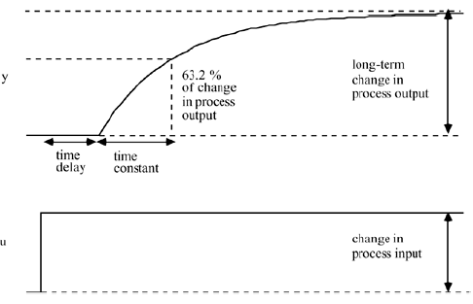

On-off control
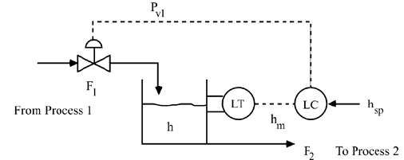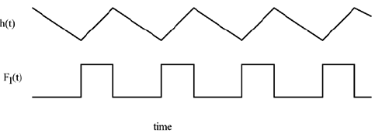
If $h≥h_{sp}+δ P_{v1}=P_{v1,min}$If $h≤h_{sp}-δ P_{v1}=P_{v1,max}$Else, $P_{v1}=current value (P_{v1,min} or P_{v1,max})$
$$2δ=dead band$$
Dead band is a measure of how an output change must occur before the setting is changed. There is a natural trade between tighter output control and periodic switching. With a small dead band, there will be small fluctuations in output, but more frequent switching of the setting. As the dead band is increased, the fluctuations in output become larger, but the heater setting is switched less often.

Proportional control $P_{v1}=b+k_{c}\left(h_{sp}-h_{m}\right) error\left(e\right)=h_{sp}-h_{m}$
A process with a positive gain requires a controller proportional gain that is also positive. A process with a negative gain would require a controller proportional gain that is also negative.
$$k_{p}=\frac{∆h}{∆P_{v}}=k_{p1}k_{v1}=\frac{∆h}{∆F}\frac{∆F}{∆P_{v}}$$
Valve gain: $k_{c}=\frac{change in flow rate}{change in signal}$
Controller transfer function | $$P_{v}-P_{v,ss}=k_{c}\left(h_{sp}-h\right)m c\left(s\right)=k_{c}e\left(s\right)=g_{c}\left(s\right)e(s)$$
Valve transfer function | $$u\left(s\right), flow through valve*g_{v}\left(s\right)=c\left(s\right), pressure to valve$$
Process transfer function | $$u\left(s\right), flow rate to tank*g_{p}\left(s\right)=y\left(s\right), tank height$$
Disturbance transfer function | $$u\left(s\right), flow rate from tank*g_{d}\left(s\right)=y\left(s\right), tank height$$
Measurement (sensor) transfer function | $$u\left(s\right), tank height*g_{m}\left(s\right)=y\left(s\right), measured height$$
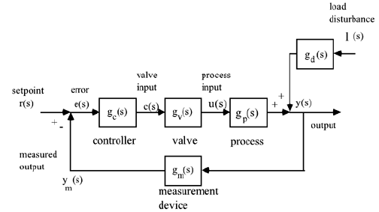

Response to setpoint change
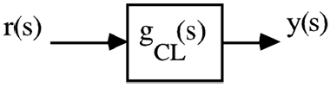
$$y\left(s\right)=g_{p}\left(s\right)u\left(s\right) input-output relationship$$
$$u\left(s\right)=g_{c}\left(s\right)e\left(s\right) controller relationship$$
$$y\left(s\right)=g_{p}\left(s\right)g_{c}\left(s\right)e\left(s\right) e\left(s\right)=r\left(s\right)-y\left(s\right) y\left(s\right)=g_{p}\left(s\right)g_{c}\left(s\right)\left(r\left(s\right)-y\left(s\right)\right) y\left(s\right)=\frac{g_{p}\left(s\right)g_{c}\left(s\right)}{1+g_{p}\left(s\right)g_{c}\left(s\right)} r(s)$$
$$g_{CL}\left(s\right)=\frac{g_{p}\left(s\right)g_{c}\left(s\right)}{1+g_{p}\left(s\right)g_{c}\left(s\right)}=\frac{\frac{k_{p}k_{c}}{τ_{p}s+1}}{1+\frac{k_{p}k_{c}}{τ_{p}s+1}}=\frac{k_{CL}}{τ_{CL}s+1}$$

