Chapter 12 Test Review
Fluid- a substance that can flow and therefore take the shape of its container.

Properties of liquid:
- Relative high density
- Relative incompressibility
- Ability to diffuse
- Surface tension- a force that tends to pull adjacent parts of a liquid’s surface togerther, thereby decreasing the surface area to the smallest possible size.
Capillary action- the attraction of the surface of a liquid to the surface of a solid.
- Vaporization- liquid to gas
  - - evaporation- particles escape from the surface of a nonboiling liquid and enter the gas state
  - - boiling
- Formation of solids- freezing, by removal of heat

Properties of solid:
- Definite shape and volume
- Melting: solid to liquid
- Definite melting point- the temperature at which a solid becomes a liquid
Supercooled liquids- substances that remain certain liquid properties even at temperatures at which they appear to be solid.
- High density and incompressibility
- Low rate of diffusion

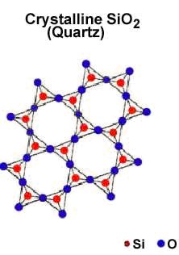 | 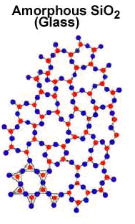
Consist of crystals, substances in which the particles are arranged in an orderly, geometric, repeating pattern. | One in which the particles are arranged randomly
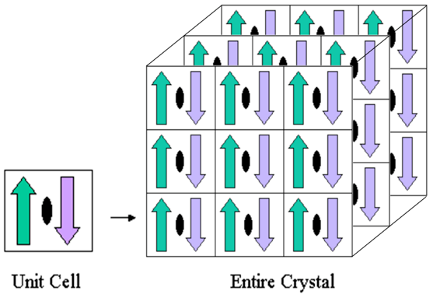

Ionic crystals  - Ionic crystals are very hard and brittle.  - They have very high melting and boiling points.  - They are poor conductors of electricity and therefore are insulators in the solid state.  - They have high heat of vaporization and so have low vapour pressure.  - When melted or dissolved in polar solvents, they conduct elecricity. | 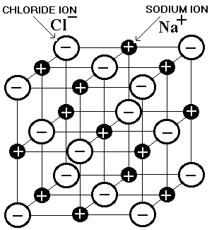
Covalent network crystals  - The covalent crystals are incompressible and hard.  - They are extremely non-volatile and have very high melting points.  - They are poor conductors of electricity at all temperatures. | 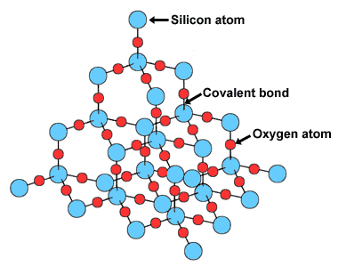
Metallic crystals  - Metallic crystals may be hard as well as soft.  - They are good conductors of heat and electricity.  - The properties of metallic crystals vary from metal to metal. | 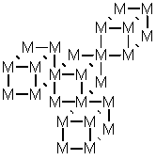
Covalent molecular crystals  - Molecular crystals are soft, compressible and can be distorted very easily.  - They have low melting and boiling points.  - These are bad conductors of electricity and are regarded as electrical insulators.  - They are volatile and have low heats of vaporization. | 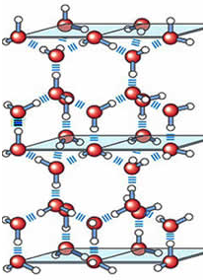

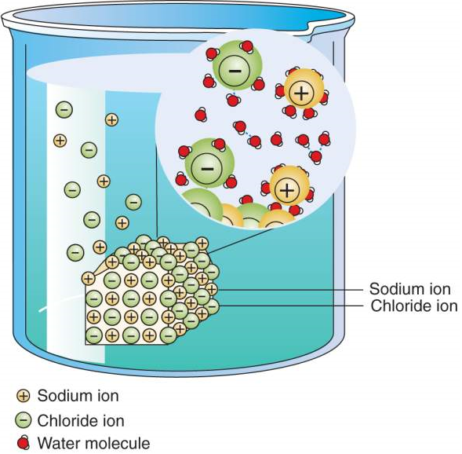
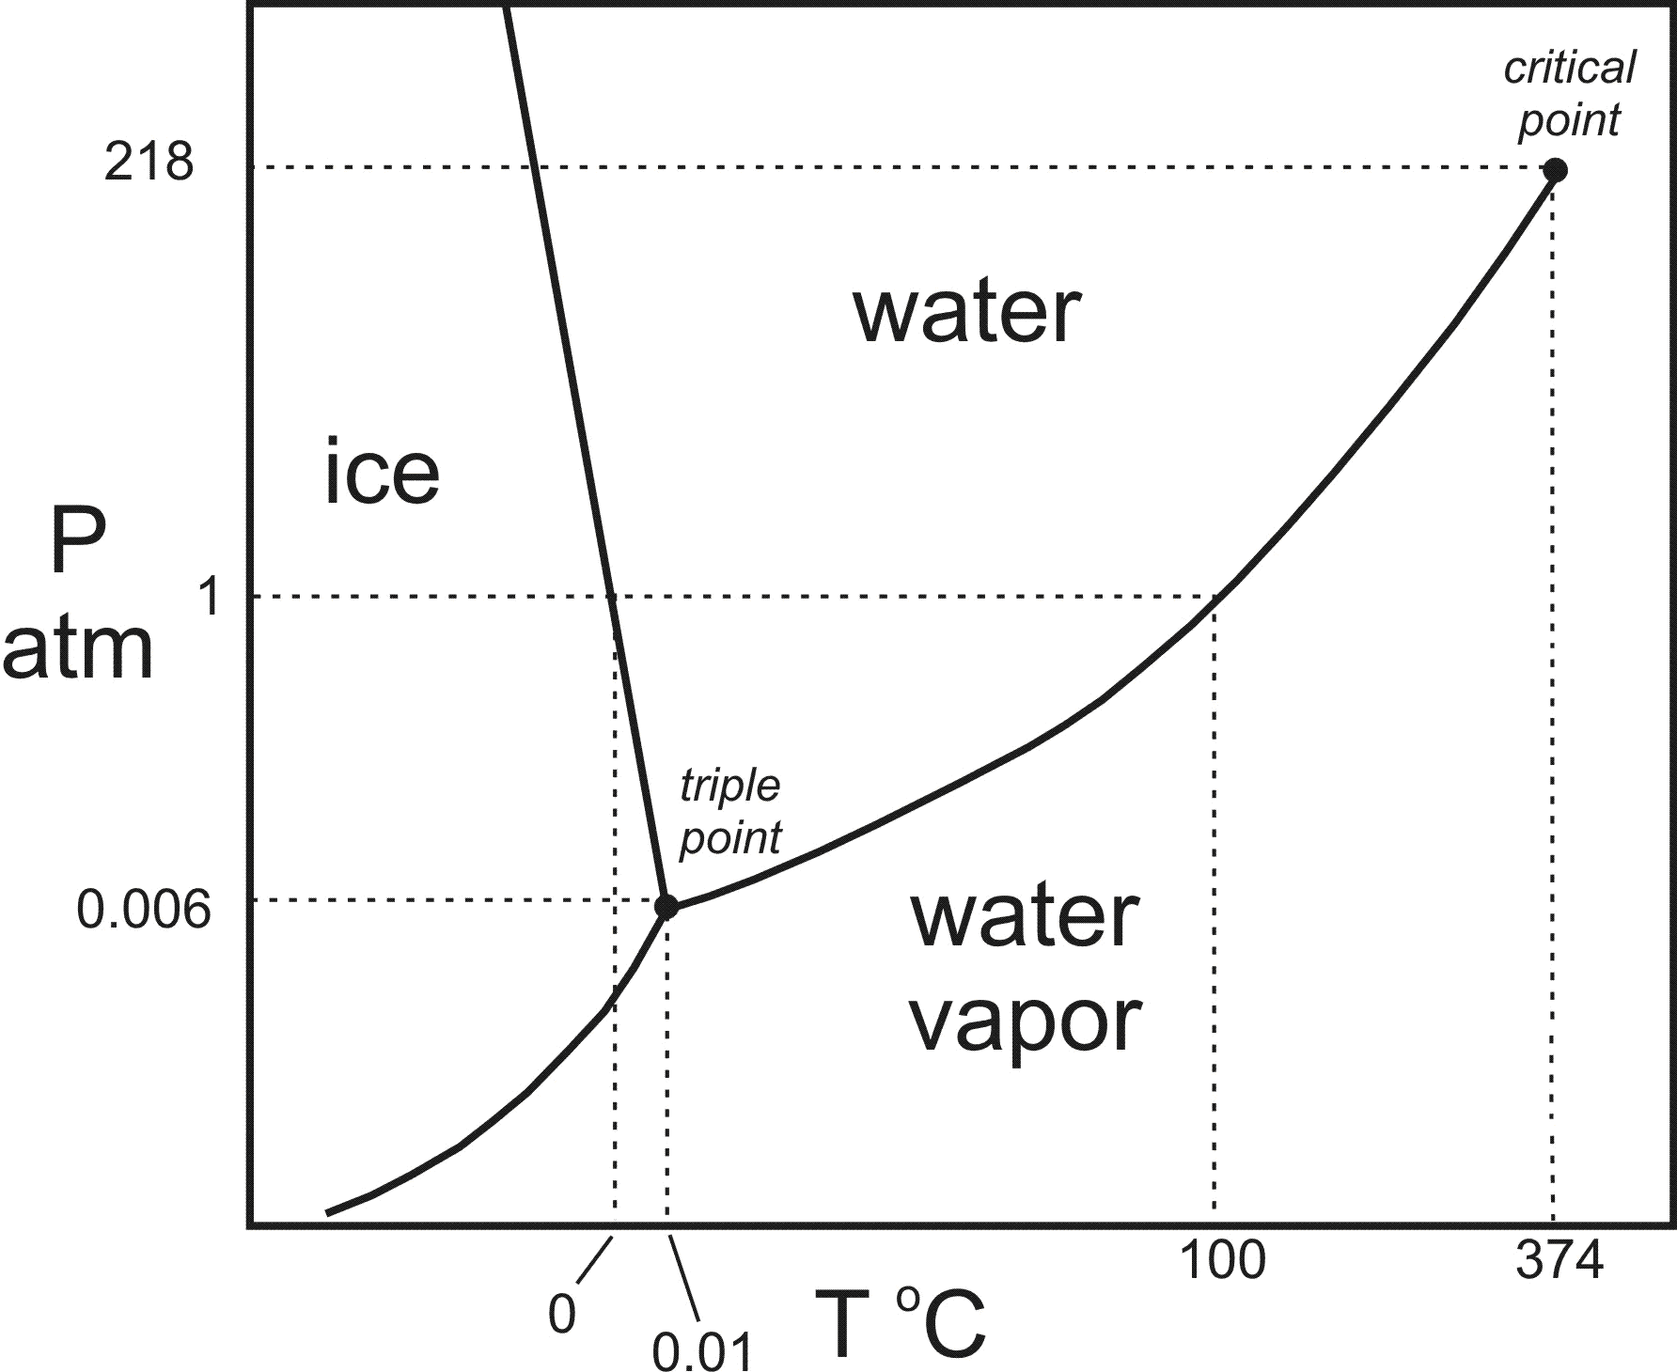 | Triple point- the temperature and presure conditions at which the solid, liquid and vapor of the substance can coexist at equilibrium.  Critical temperature- temperature above which the substance cannot exist in the liquid state.  Critical pressure- the lowest pressure at which the substance can exist as a liquid at the critical temperature.  Critical point- indication of the critical temperature and pressure.

