CEE111 First Midterm Review Sheet
Air quality engineering issues  - Acid deposition – economic and ecosystem damage  - Stratospheric ozone depletion - CFCs  - Hazardous air pollutants  - Biomass cookstoves | Hazardous wastes  - Corrosivity (high or low pH)  - Ignitability  - Reactivity  - Toxicity

Concentration
- %: percent, 1 parts species per 100 parts solution
- ‰: per mil, 1 parts species per 1000 parts solution
- ppm: parts per million, 1 parts species per 10⁶ parts solution
- ppb: parts per billion, 1 parts species per 10⁹ parts solution
- ppt: parts per trillion, 1 parts species per 10¹² parts solution

$C_{i}=MW_{i}\left[i\right] \left[i\right]$molar concentration of i $MW_{i}$ molar mass of i $C_{i}$ mass concentration of i
$C_{i}=ρ_{s}X_{i} X_{i}$ mass fraction of i $ρ_{s}$ density of solution $C_{i}$ mass concentration of i
$$C_{air}=\frac{P}{RT}=\frac{1 atm}{0.08206 \frac{L atm}{K mol}*293K}=41.6\frac{mol}{m^{3}} Y_{i}=\frac{C_{i}}{C_{air}}$$

Mass balance $in-out+generation=accumulation Q_{total }= Q_{1 }+Q_{2 } C_{total }=C_{1}Q_{1 } + C_{2}Q_{2 }$
Accuracy describes the relationship between the average of several repeated determinations and the goal.
Precision describes the level of variability within several repeated determinations.
$$τ_{r}=\frac{Stock size}{flow rate}$$
Density of water is greatest at 4°C, at $1000\frac{kg}{m^{3}}$. Density of water is higher in liquid than in solid.

Composition of dry air
N2 ~ 78.08%
O2 ~ 20.95%
Argon ~ 0.93 %
CO2 ~ 0.035 ppm

$$P_{i}=\frac{n_{i}}{V}RT where P_{i} is the partial pressure of gaseous species i$$
$$Y_{i}=\frac{n_{i}}{n}=\frac{P_{i}}{P}$$
$${MW}_{dry,air}=\left(78.08\%*28\right)+\left(20.95\%*32\right)+\left(0.93 \%*40\right)+\left(0.035\%*44\right)=28.95\frac{g}{mol }$$
$${MW}_{wet,air}=18Y_{H_{2}O}+{MW}_{dry,air}*\left(1-Y_{H_{2}O}\right)$$
$$Y_{i,moist}=Y_{i,dry}*\left(1-Y_{H_{2}O}\right)$$
$$C_{i}={MW}_{i}\frac{n_{i}}{V}={Y_{i}MW}_{i}\frac{n}{V}={Y_{i}MW}_{i}\frac{P}{RT}$$

Electroneutrality, $\sum{z_{i}C_{i}=0}$Ionic strength, $I=\frac{1}{2}\sum{z_{i}^{2}C_{i}}$
Hardness, the sum of the normalities of all multivalent cations. Main cations, ${Ca}^{2+} {Mg}^{2+}$
Classification | Hardness (meq/L) | Hardness (mg/L as CaCO3)
Soft | <1.5 | <75
Moderately hard | 1.5~3 | 75~150
Hard | 3~6 | 150~300
Very hard | >6 | >300
Compute total harness (TH), compute$Nc = \left[HCO_{3}^{-}\right]+2\left[CO_{3}^{2-}\right]$
If $Nc<TH$ CH = Nc NCH = TH-CH
If $Nc>TH$ CH = TH NCH = 0

Alkalinity, $A = \left[{OH}^{-}\right]+\left[HCO_{3}^{-}\right]+2\left[CO_{3}^{2-}\right]-[H^{+}]$

Organic compounds of environmental concern  Formaldehyde  CHC-12  Benzene  Perchloroethylene  2,3,7,8-TCDD (dioxin)  Benzo(a)pyrene | Toxic metals  Cadmium  Chromium  Lead  Mercury
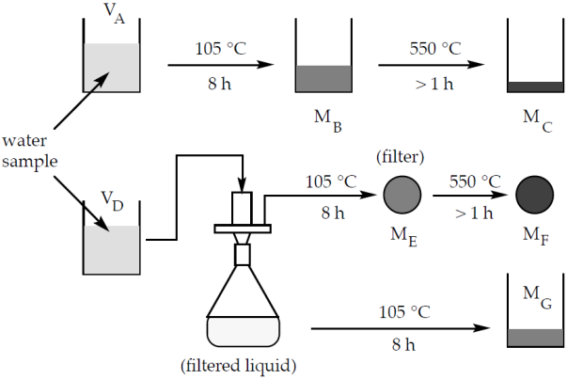 | $$TS=\frac{M_{B}}{V_{A}}$$  $$TDS=\frac{M_{G}}{V_{D}} =TS-SS$$  $$SS=\frac{M_{E}}{V_{D}}$$  $$TVS=\frac{M_{B}-M_{C}}{V_{A}}$$  $$VVS=\frac{M_{E}-M_{F}}{V_{D}}$$
$$aA+bB→cC+dD$$
$R_{f}=k{\left[A\right]}^{α}{\left[B\right]}^{β} rate constant k, empirical coefficients α and β$If$α=a, β=b$, elementary reaction
$$R_{f}=-\frac{1}{a}\frac{d\left[A\right]}{dt}=-\frac{1}{b}\frac{d\left[B\right]}{dt}=\frac{1}{c}\frac{d\left[C\right]}{dt}=\frac{1}{d}\frac{d\left[D\right]}{dt}$$
Zero order $\frac{d\left[A\right]}{dt}=-k_{o} \left[A\right]={\left[A\right]}_{o}-kt$First order $\frac{d\left[A\right]}{dt}=-k_{1}\left[A\right] \left[A\right]={\left[A\right]}_{o}e^{-k_{1}t}$
Second order $\frac{d\left[A\right]}{dt}=-{2k}_{2}{\left[A\right]}^{2} \left[A\right]=\frac{{\left[A\right]}_{o}}{1+{2k}_{2}{t\left[A\right]}_{o}}$
A system is at equilibrium:
- does not vary in time
- is internally uniform
- has no net flows of mass, heat, or species within the system and its surroundings
- net rate of chemical reactions equal to 0
$$K=\frac{k_{f}}{k_{r}}=\frac{{\left[C\right]}^{c}{\left[D\right]}^{d}}{{\left[A\right]}^{a}{\left[B\right]}^{b}}$$

$$H_{2}O\left(l\right) H^{+}\left(aq\right)+{OH}^{-}\left(aq\right) K_{w}=\left[H^{+}\right]\left[OH^{-}\right]={10}^{-14} K_{w} is a function of T$$
$$A\left(s\right) B^{+}\left(aq\right)+C^{-}\left(aq\right) K_{sp}=\left[B^{+}\right]\left[C^{-}\right]$$

$$Relative humidity \left(RH\right)= 100\% * \frac{P_{H_{2}O}}{{P^{o}}_{H_{2}O}\left(T\right)saturation vapor pressure of water at T}$$
The equilibrium partial pressure of species i is equal to vapor pressure equilibrium constant at T.

$$C_{w}, aqueous phase species concentration (M)=\frac{P_{g}, gas phase species partial pressure (atm)}{Henry^{'}s law constant \left(atm M^{-1}\right)}$$
Adsorption- surface uptake
Absorption- distributed uptake
Sorption- either one or both

Equilibrium sorption described by sorption isotherms
$$linear:q_{e}=K_{ads}C_{e}$$
$$Langmuir: q_{e}=q_{max}\frac{bC_{e}}{1+bC_{e}}$$
$$Freundlich: q_{e}=K_{f}C_{e}^{\frac{1}{n}}$$
Equations you need for the dissociation of weak acic HA
$${water dissociation: K}_{w}=\left[H^{+}\right]\left[OH^{-}\right]$$
$$material balance on A: C_{total}=\left[A^{-}\right]+[HA]$$
$${acid dissociation: K}_{A}=\frac{\left[H^{+}\right]\left[A^{-}\right]}{[HA]}=\frac{\left[H^{+}\right]\left[A^{-}\right]}{C_{total}-\left[A^{-}\right]}$$
$$K_{A}C_{total}-K_{A}\left[A^{-}\right]=\left[H^{+}\right]\left[A^{-}\right]$$
$$\left[A^{-}\right]=\frac{K_{A}C_{total}}{K_{A}+\left[H^{+}\right]}$$
$$electroneutrality: \left[H^{+}\right]=\frac{K_{w}}{\left[H^{+}\right]}+\frac{C_{total}K_{A}}{K_{A}+\left[H^{+}\right]}$$

Carbonate system  ${CO}_{2}\left(g\right)$ carbon dioxide gas  ${CO}_{2}\left(aq\right)$ dissolved carbon dioxide  ${H_{2}CO}_{3}\left(aq\right)$ carbonic acid  ${HCO}_{3}^{-}\left(aq\right)$ bicarbonate ion  ${CO}_{3}^{2-}\left(aq\right)$ carbonate ion  ${CaCO}_{3}\left(s\right)$ calcium carbonate  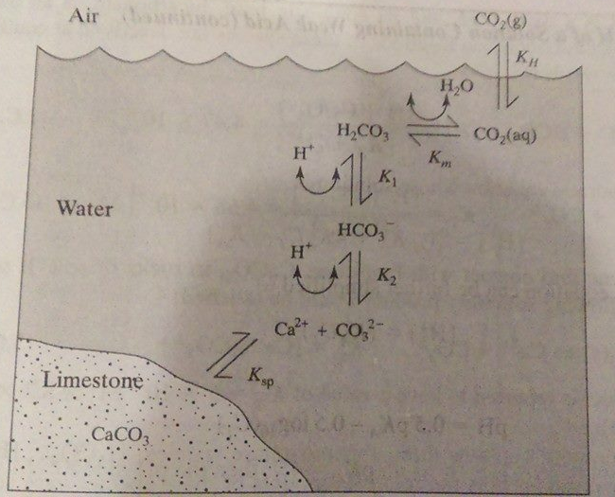 | $$\left[{CO}_{2}\left(aq\right)\right]=K_{H}P_{{CO}_{2}} K_{H}=0.034\frac{M}{atm}$$  $$\frac{\left[H_{2}{CO}_{3}\right]}{{[CO}_{2}\left(aq\right)]}=K_{m}=1.58*{10}^{-3}$$  $${[H}_{2}{CO}_{3}*]={[CO}_{2}\left(aq\right)]+\left[H_{2}{CO}_{3}\right]={[CO}_{2}\left(aq\right)](1+K_{m})$$  $$H_{2}{CO}_{3}→H^{+}+{HCO}_{3}^{-}$$  $$K_{1}=\frac{\left[H^{+}\right]\left[{HCO}_{3}^{-}\right]}{{[H}_{2}{CO}_{3}]}=4.47*{10}^{-7}M$$  $${HCO}_{3}^{-}→H^{+}+{CO}_{3}^{2-}$$  $$K_{2}=\frac{\left[H^{+}\right]\left[{CO}_{3}^{2-}\right]}{{[HCO}_{3}^{-}]}=4.68*{10}^{-11}M$$  $${CaCO}_{3}→{Ca}^{2+}+{CO}_{3}^{2-} K_{sp}=\left[{Ca}^{2+}\right][{CO}_{3}^{2-}]$$  $$C_{carbonate}={[H}_{2}{CO}_{3}]+\left[H{CO}_{3}^{-}\right]+[{CO}_{3}^{2-}]$$  $$α_{H_{2}{CO}_{3}*}=\frac{{[H}_{2}{CO}_{3}*]}{C_{carbonate}}=\frac{{\left[H^{+}\right]}^{2}}{{\left[H^{+}\right]}^{2}+K_{1}\left[H^{+}\right]+K_{1}K_{2}}$$  $$α_{H{CO}_{3}^{-}}=\frac{\left[H{CO}_{3}^{-}\right]}{C_{carbonate}}=\frac{K_{1}\left[H^{+}\right]}{{\left[H^{+}\right]}^{2}+K_{1}\left[H^{+}\right]+K_{1}K_{2}}$$  $$α_{{CO}_{3}^{2-}}=\frac{\left[{CO}_{3}^{2-}\right]}{C_{carbonate}}=\frac{K_{1}K_{2}}{{\left[H^{+}\right]}^{2}+K_{1}\left[H^{+}\right]+K_{1}K_{2}}$$
pH of water in a limestone aquifer  $$\left[H_{2}{CO}_{3}*\right]=\frac{\left[H{CO}_{3}^{-}\right][H^{+}]}{K_{1}}$$  $$\left[H{CO}_{3}^{-}\right]=\frac{\left[H^{+}\right]\left[{CO}_{3}^{2-}\right]}{K_{2}}$$  $$\left[H^{+}\right]\left[OH^{-}\right]=K_{w}$$  $$\left[{Ca}^{2+}\right]\left[{CO}_{3}^{2-}\right]=K_{sp}$$  $$2\left[{Ca}^{2+}\right]+\left[H^{+}\right]=\left[OH^{-}\right]+\left[H{CO}_{3}^{-}\right]+2\left[{CO}_{3}^{2-}\right]$$  $$\left[{Ca}^{2+}\right]=\left[H_{2}{CO}_{3}*\right]+\left[H{CO}_{3}^{-}\right]+\left[{CO}_{3}^{2-}\right]$$  $$\frac{{2K}_{sp}}{\left[{CO}_{3}^{2-}\right]}+\left[H^{+}\right]=\frac{K_{w}}{\left[H^{+}\right]}+\frac{\left[H^{+}\right]\left[{CO}_{3}^{2-}\right]}{K_{2}}+2\left[{CO}_{3}^{2-}\right]$$  $$\left[{CO}_{3}^{2-}\right]=K_{sp}^{\frac{1}{2}}{\left(\frac{{\left[H^{+}\right]}^{2}}{K_{1}K_{2}}+\frac{\left[H^{+}\right]}{K_{2}}+1\right)}^{-\frac{1}{2}}$$ | pH of pristine rainwater  $$\left[H_{2}{CO}_{3}*\right]=(1+K_{m})K_{H}P_{{CO}_{2}}$$  $$\left[H{CO}_{3}^{-}\right]=\frac{K_{1}\left[H_{2}{CO}_{3}*\right]}{[H^{+}]}$$  $$\left[{CO}_{3}^{2-}\right]=\frac{K_{2}\left[H{CO}_{3}^{-}\right]}{[H^{+}]}$$  $$\left[H^{+}\right]\left[OH^{-}\right]=K_{w}$$  $$\left[H^{+}\right]=\left[OH^{-}\right]+\left[H{CO}_{3}^{-}\right]+2\left[{CO}_{3}^{2-}\right]$$  $$\left[H^{+}\right]=\frac{K_{w}}{\left[H^{+}\right]} +\frac{K_{1}(1+K_{m})K_{H}P_{{CO}_{2}}}{[H^{+}]}+2\frac{K_{1}K_{2}(1+K_{m})K_{H}P_{{CO}_{2}}}{{\left[H^{+}\right]}^{2}}$$

