Chemical Engineering 162 First Midterm Review
Manipulated input- one that can be adjusted by the control system
Disturbance input- one that affects the process outputs but that cannot be adjusted by the control system
Output- measured or unmeasured
Constraints- soft or hard
Operating characteristics- continuous, batch, semicontinuous/semibatch

Positive gain- an increase in a process input leads to an increase in the process output
Negative gain- an increase in a process input leads to a decrease in the process output

Fail-closed / air-to-open- if signal is lost, valve will close
Fail-open / air-to-close- if signal is lost, valve will open
Feedforward- measures disturbance variable and sends this value to a controller, which adjusts the manipulated variable
Feedback- measures the output variable, compares the value to the desired output value, and uses this information to adjust the manipulated variable
Setpoint- desired value of the measured process output

Mass balances $\frac{dV}{dt}=F_{1}-F_{2} \frac{dh}{dt}=\frac{F_{1}-F_{2}}{A} \frac{dM}{dt}=\dot{m_{in}}-\dot{m_{out}}$
$$\frac{dn}{dt}=q_{i}-q=\frac{V}{RT}\frac{dP}{dt} \frac{dP}{dt}=\frac{RT}{V}\left(q_{i}-q\right) q=β(P-P_{h})$$
$$\dot{x}=f\left(x,u,p\right) \dot{y}=g\left(x,u,p\right)$$
x is the vector of state variables, u is the vector of input variables, p is the vector of parameters, y is the vector of output

Energy balances $\frac{dT}{dt}=\frac{F_{i}}{V}\left(T_{i}-T\right)+\frac{Q}{VρC_{P}} u=Q-Q_{s} y=T-T_{s} τ_{p}\frac{dy}{dt}=-y+k_{p}u$
$$\frac{dx}{dt}=f\left(x\right) f\left(x\right)=f\left(x_{s}\right)+{\left.\frac{∂f}{∂x}\left(x-x_{s}\right)\right|}_{x_{s}} f\left(x,u\right)=f\left(x_{s},u_{s}\right)+{\left.\frac{∂f}{∂x}\left(x-x_{s}\right)\right|}_{x_{s}}+{\left.\frac{∂f}{∂u}\left(u-u_{s}\right)\right|}_{u_{s}}$$
$${\dot{x}}^{'}=Ax^{'}+Bu^{'} {\dot{y}}^{'}=Cx^{'}+Du^{'} A_{ij}=\frac{∂f_{i}}{∂x_{j}} B_{ij}=\frac{∂f_{i}}{∂u_{j}} C_{ij}=\frac{∂g_{i}}{∂x_{j}} D_{ij}=\frac{∂g_{i}}{∂u_{j}}$$
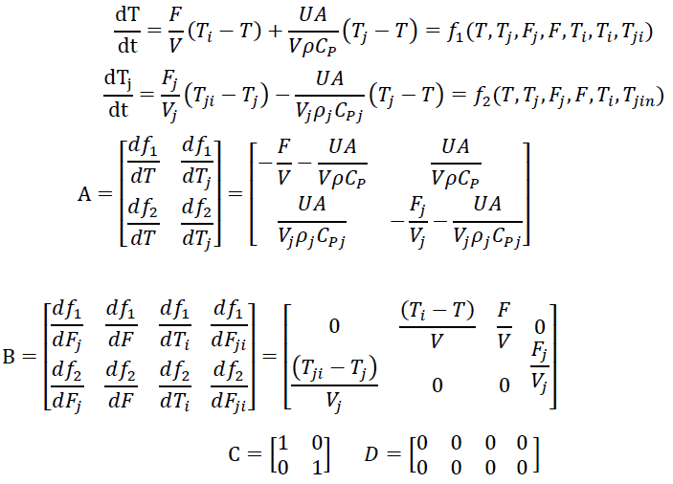
Eigenvalue $\det\left(λI-A\right)=0 λ=\frac{a_{11}+a_{22}±\sqrt{{\left(a_{11}+a_{22}\right)}^{2}-4\left(a_{11}a_{22}-a_{12}a_{21}\right)}}{2}$
If all eigenvalues are negative, then the system is stable. If any single eigenvalue is positive, the system is unstable
Laplace Transform
$$L\left[f\left(t\right)\right]=F\left(s\right)=\int_{0}^{∞}{f\left(t\right)e^{-st}dt}$$
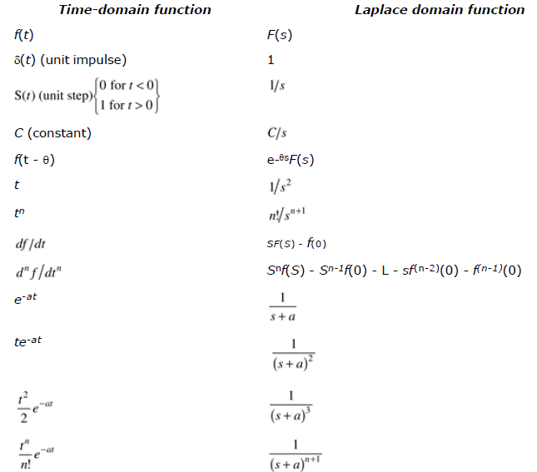 | 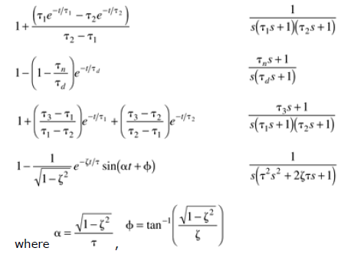  $$final value theorem: \lim_{t→∞}{f\left(t\right)}=\lim_{s→0}\left[sF\left(s\right)\right]$$  $$initial value theorem: \lim_{t→0}{f\left(t\right)}=\lim_{s→∞}\left[sF\left(s\right)\right]$$
$$\frac{d^{n}y}{dt^{n}}+a_{n-1}\frac{d^{n-1}y}{dt^{n-1}}+…+a_{0}y=b_{n-1}\frac{d^{n-1}u}{dt^{n-1}}+…+b_{0}u L\left[\frac{d^{n}y}{dt^{n}}\right]=s^{n}Y\left(s\right)$$
$$Y\left(s\right)=\frac{N\left(s\right)}{D\left(s\right)}=\frac{C_{1}}{s-a}+\frac{C_{2}}{s-b}+… y\left(t\right)=C_{1}e^{-at}+C_{2}e^{-bt}+…$$
$$Y\left(s\right)=\frac{C_{1}}{s-a}+\frac{C_{2}}{{\left(s-a\right)}^{2}}+… y\left(t\right)=C_{1}e^{-at}+C_{2}te^{-at}+\frac{C_{3}}{2}t^{2}e^{-at}…$$
Transfer functions $Y\left(s\right)=g\left(s\right)U\left(s\right) g\left(s\right)=\frac{Y\left(s\right)}{U\left(s\right)}$The roots of numerator are zeroes. The roots of denominator are poles.
2nd order systems
$$a_{0}\frac{d^{2}y}{dt^{2}}+a_{1}\frac{dy}{dt}+a_{0}y=b_{0}u\left(t\right) τ^{2}\frac{d^{2}y}{dt^{2}}+2τφ\frac{dy}{dt}+y=ku\left(t\right) τ^{2}=\frac{a_{2}}{a_{0}} 2τφ=\frac{a_{1}}{a_{0}} k=\frac{b_{0}}{a_{0}}$$
$$τ^{2}\left[s^{2}y\left(s\right)+sy\left(0\right)+\dot{y}\left(0\right)\right]+2τφ\left[sy\left(s\right)-y\left(0\right)\right]+y\left(s\right)=ku\left(s\right) y\left(s\right)=\frac{k}{τ^{2}s^{2}+2τφs+1}u\left(s\right)$$
$$two poles: p_{1}=-\frac{φ}{τ}+\frac{\sqrt{φ^{2}-1}}{τ} p_{2}=-\frac{φ}{τ}-\frac{\sqrt{φ^{2}-1}}{τ}$$
Damping factor | Pole location | Characteristic behavior |  | Step response
$$φ>1$$ | Two real, distinct roots | Overdamped |  | $$τ^{2}s^{2}+2τφs+1=\left(τ_{1}s+1\right)\left(τ_{2}s+1\right)$$  $$τ_{1}=\frac{τ}{φ-\sqrt{φ^{2}-1}} τ_{2}=\frac{τ}{φ+\sqrt{φ^{2}-1}}$$  $$y\left(t\right)=k∆u\left[\frac{1+τ_{1}e^{-\frac{t}{τ_{1}}}-τ_{2}e^{-\frac{t}{τ_{2}}}}{τ_{2}-τ_{1}}\right]$$
$$φ=1$$ | Two real, equal roots | Critically damped |  | $$y\left(t\right)=k∆u\left[1-\left(1+\frac{t}{τ}\right)e^{-\frac{t}{τ}}\right]$$
$$φ<1$$ | Two complex conjugate roots | Underdamped |  | $$y\left(t\right)=k∆u\left[1-\frac{1}{\sqrt{1-φ^{2}}}e^{-\frac{φt}{τ}}\sin{αt+β}\right]$$  $$α=\frac{\sqrt{1-φ^{2}}}{τ} β=\tan^{-1}{(\frac{\sqrt{1-φ^{2}}}{φ})}$$
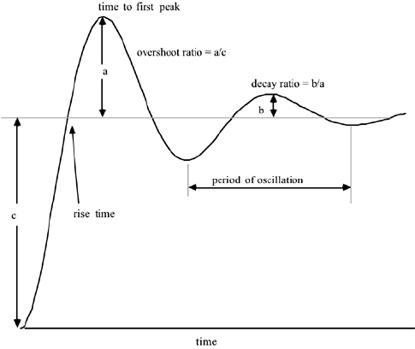 |  |  | Process gain, $k_{p}=\frac{∆y}{∆u}=\frac{y_{ss}-y_{0} }{∆u}=c$  To calculate $τ,$ see where the first peak occurs, and divide that by $\frac{t}{τ}$.  $$decay ratio=\frac{b}{a}$$  $$overshoot ratio=\frac{a}{c}=\frac{a}{∆y}$$
$$g\left(s\right)=\frac{k_{p}\left(τ_{n}s+1\right)}{\left(τ_{1}s+1\right)(τ_{2}s+1)}=\frac{k_{pz}\left(s-z_{1}\right)}{(s-p_{1})(s-p_{2})} k_{pz}=\frac{kτ_{n}}{τ_{1}τ_{2}} p_{1}=-\frac{1}{τ_{1}} p_{2}=-\frac{1}{τ_{2}} z_{1}=-\frac{1}{τ+n }$$
$$y\left(t\right)=k_{p}∆u\left[1+\left(\frac{τ_{n}-τ_{1}}{τ_{1}-τ_{2}}\right)e^{-\frac{t}{τ_{1}}}+\left(\frac{τ_{n}-τ_{2}}{τ_{1}-τ_{2}}\right)e^{-\frac{t}{τ_{2}}}\right]$$
Lead-lag behavior $g\left(s\right)=k_{p}\frac{\left(τ_{n}s+1\right)}{τ_{p}s+1} y\left(t\right)=k_{p}∆u\left[1-\left(1-\frac{τ_{n}}{τ_{p}}\right)e^{-\frac{t}{τ_{p}}}\right]$
Poles and zeroes $g\left(s\right)=\frac{b_{m}s^{m}+b_{m-1}s^{m-1}+…+b_{1}s+b_{0}}{a_{n}s^{n}+a_{n-1}s^{n-1}+…+a_{1}s+a_{0}}=\frac{k_{pz}\left(s-z_{1}\right)\left(s-z_{2}\right)…(s-z_{m})}{\left(s-p_{1}\right)\left(s-p_{2}\right)…(s-p_{m})}=\frac{k_{p}\left(τ_{n1}s+1\right)\left(τ_{n2}s+1\right)…(τ_{nm}s+1)}{\left(τ_{p1}s+1\right)\left(τ_{p2}s+1\right)…(τ_{pm}s+1)}$
$$z_{1},z_{2}…, z_{m} are zeroes p_{1},p_{2}…,p_{m} are poles$$
If zero is real, inverse response. If pole is real, unstable. As poles become more negative, the response is faster.
As the imaginary/real ratio increases, the response becomes more oscillatory.
Dead time $g_{p}\left(s\right)=\frac{k_{p}e^{-θs}}{τ_{p}s+1}, a time dealy of θ time units$
1st order Pade approximation$, e^{-θs}=\frac{-\frac{θ}{2}s+1}{\frac{θ}{2}s+1}$ 2nd order Pade approximation$e^{-θs}=\frac{\frac{θ^{2}}{12}s^{2}-\frac{θ}{2}s+1}{\frac{θ^{2}}{12}s^{2}+\frac{θ}{2}s+1}$
$$\frac{dx}{dt}=Ax+Bu y=Cx+Du sx\left(s\right)=Ax\left(s\right)+Bu\left(s\right) y\left(s\right)=Cx\left(s\right)+Du\left(s\right)$$
$$x\left(s\right)={\left(sI-A\right)}^{-1}Bu\left(s\right) y\left(s\right)=[{C\left(sI-A\right)}^{-1}B+D]u\left(s\right)$$
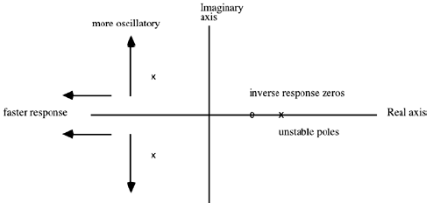
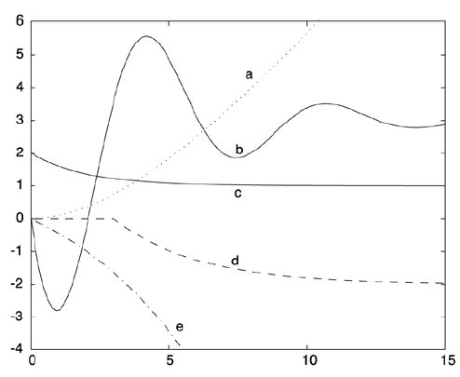 |  | b, because it is the only 2nd order  d, because there is a 3-second dead time  e, because the pole is positive, so the response is unstable  a, initial value theorem, final value theorem  e, lead-lag (start at 2), also use final value theorem or initial value theorem
$$y\left(s\right)=\frac{k_{p}e^{-θs}}{τ_{p}s+1} u\left(s\right) y\left(t\right)=k_{p}∆u\left[1-e^{-\frac{t-θ}{τ}}\right] if t=τ+θ, y\left(t\right)={0.632 k}_{p}∆u$$
$$t_{63.2\%}=τ_{p}+θ use this to find τ, the time it takes to reach 63.2\% of the process gain$$
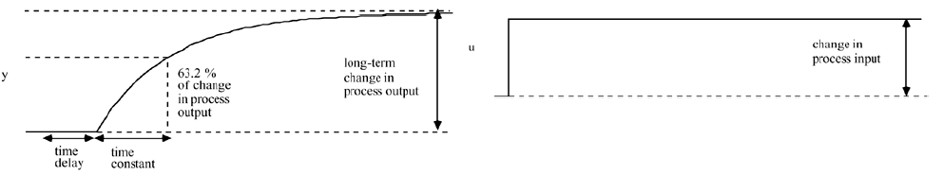
On-off control
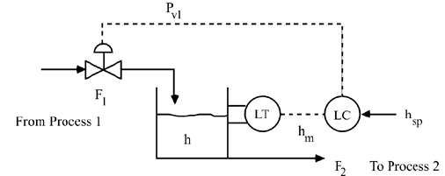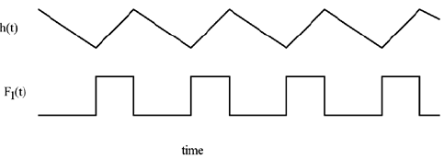
If $h≥h_{sp}+δ P_{v1}=P_{v1,min}$If $h≤h_{sp}-δ P_{v1}=P_{v1,max}$Else, $P_{v1}=current value (P_{v1,min} or P_{v1,max})$
$$2δ=dead band$$
Dead band is a measure of how an output change must occur before the setting is changed. There is a natural trade between tighter output control and periodic switching. With a small dead band, there will be small fluctuations in output, but more frequent switching of the setting. As the dead band is increased, the fluctuations in output become larger, but the heater setting is switched less often.

Proportional control $P_{v1}=b+k_{c}\left(h_{sp}-h_{m}\right) error\left(e\right)=h_{sp}-h_{m}$
A process with a positive gain requires a controller proportional gain that is also positive. A process with a negative gain would require a controller proportional gain that is also negative.
$$k_{p}=\frac{∆h}{∆P_{v}}=k_{p1}k_{v1}=\frac{∆h}{∆F}\frac{∆F}{∆P_{v}}$$
Valve gain: $k_{c}=\frac{change in flow rate}{change in signal}$
Controller transfer function | $$P_{v}-P_{v,ss}=k_{c}\left(h_{sp}-h\right)m c\left(s\right)=k_{c}e\left(s\right)=g_{c}\left(s\right)e(s)$$
Valve transfer function | $$u\left(s\right), flow through valve*g_{v}\left(s\right)=c\left(s\right), pressure to valve$$
Process transfer function | $$u\left(s\right), flow rate to tank*g_{p}\left(s\right)=y\left(s\right), tank height$$
Disturbance transfer function | $$u\left(s\right), flow rate from tank*g_{d}\left(s\right)=y\left(s\right), tank height$$
Measurement (sensor) transfer function | $$u\left(s\right), tank height*g_{m}\left(s\right)=y\left(s\right), measured height$$
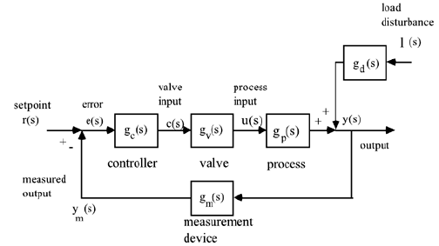
$$y\left(s\right)=g_{p}\left(s\right)u\left(s\right) input-output relationship$$
$$u\left(s\right)=g_{c}\left(s\right)e\left(s\right) controller relationship$$
$$y\left(s\right)=g_{p}\left(s\right)g_{c}\left(s\right)e\left(s\right) e\left(s\right)=r\left(s\right)-y\left(s\right) y\left(s\right)=g_{p}\left(s\right)g_{c}\left(s\right)\left(r\left(s\right)-y\left(s\right)\right) y\left(s\right)=\frac{g_{p}\left(s\right)g_{c}\left(s\right)}{1+g_{p}\left(s\right)g_{c}\left(s\right)} r(s)$$
$$g_{CL}\left(s\right)=\frac{g_{p}\left(s\right)g_{c}\left(s\right)}{1+g_{p}\left(s\right)g_{c}\left(s\right)}=\frac{\frac{k_{p}k_{c}}{τ_{p}s+1}}{1+\frac{k_{p}k_{c}}{τ_{p}s+1}}=\frac{k_{CL}}{τ_{CL}s+1}$$
Cascade controller
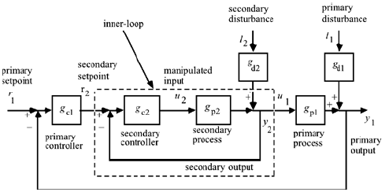 | $$y_{1}=\frac{g_{c2}g_{p2}g_{p1}}{1+g_{c2}g_{p2}}r_{2}+\frac{g_{d2}g_{p1}}{1+g_{c2}g_{p2}}l_{2}+g_{d1}l_{1}$$  $$g_{p1,eff}=\frac{g_{c2}g_{p2}}{1+g_{c2}g_{p2}}g_{p1}=g_{c2cl}g_{p1}$$  $$y_{1}=\frac{g_{c1}g_{p1,eff}}{g_{c1}g_{p1,eff}+1}r_{1}$$  $$setting g_{c2cl}=1 y_{1}=\frac{g_{c1}g_{p1}}{g_{c1}g_{p1}+1}r_{1}$$
- Cascade control can be successfully used to reject secondary-process disturbances when the primary process has a much larger time constant and a time delay or RHP zero while the secondary process has a small time constant and little or no dead time or nonminimum phase (RHP zeros) behavior.
- The most common cascade-control loop involves a flow controller as the inner loop. This type of loop easily rejects disturbances in fluid stream pressure, either upstream or downstream of the valve.
- The inner loop in a cascade-control strategy should be tuned before the outer loop. After the inner loop is tuned, and closed, the outer loop should be tuned using knowledge of the dynamics of the inner loop.
- There is little or no advantage to using cascade control if the secondary process is not significantly faster than the primary process dynamics. In particular, if there is much dead time in the secondary process, or if there is an RHP zero, it is unlikely that cascade control will be much better than standard feedback control.
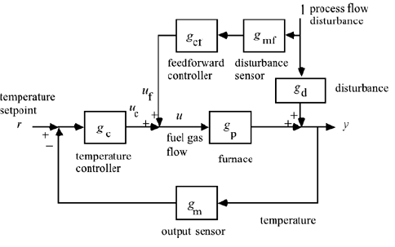 | $$y=\frac{g_{d}+g_{p}g_{cf}g_{mf}}{1+g_{p}g_{c}g_{m}}l+\frac{g_{p}g_{c}}{l+g_{p}g_{c}g_{m}}r$$  Assume no setpoint change, r = 0  Since we don’t want output variable to change  $$g_{d}+g_{p}g_{cf}g_{mf}=0$$  Disturbance measurement has no dynamics $g_{cf}=-\frac{g_{d}}{g_{p}}$  If first order process and disturbance  $$g_{p}=\frac{k_{p}}{τ_{p}s+1} g_{d}=\frac{k_{d}}{τ_{d}s+1}$$  $$g_{cf}=-\frac{k_{d}}{k_{p}}\frac{τ_{p}s+1}{τ_{d}s+1}$$
Windup
If $v<u_{min}$ then u =$u_{min}$
If $u_{min}<v<u_{max}$ then u =$v$
If $v>u_{max}$ then u =$u_{max}$
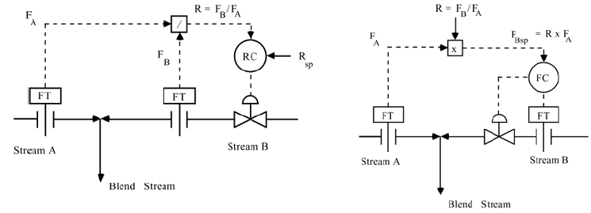
$$y=\frac{F_{B}}{F_{A}} u=F_{B} k_{p}=\frac{dy}{du}=\frac{1}{F_{A}}$$ | $$y=F_{B} u=F_{B} k_{p}=\frac{dy}{du}=1, this is preferable$$
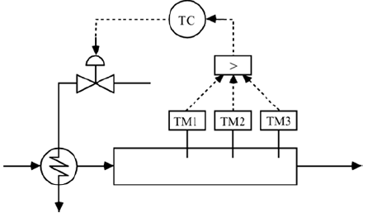$T=max⁡(T_{1},T_{2},T_{3})$

