Last Economics Review Sheet
EddY
Absolute advantage- the ability to produce a particular good with fewer resources than another country
Comparative advantage- the ability to produce a particular good at a lower opportunity cost than another country
The theory of comparative advantage- a country should specialize in producing the good that the country is efficient in producing (comparative advantage), and trade that good for the other goods that the country is inefficient in producing

Flaws in the theory of comparative advantage
- Doesn’t address winners and losers in the country (while a country specializes, it is good for the country as a whole, but it might be bad for certain groups of people in the country)
- Assumes factors within the country are perfectly mobile- can’t shift all factors to specialization
- Static model - doesn’t address potential for changes (in factor endowments, R&D, labor, etc.)
- Ignores externalities – positive and negative (while a country is good at producing something, it might be very polluting and create many negative effects; while a country specializes in producing something, it is overlooking the positive externalities brought by producing that other good)
- Ignores economies of scale (a country is not efficient at producing at a small scale, it can produce it efficiently at a large scale; it just needs that extra boost)
- Ignores national security and issues of inter-dependence (if a country’s entire supply of goods depends on another country from trading, it creates inter-dependence; if either of the countries encounter problems, both countries are harmed)

Trade barriers
Tariffs- tax charged on imported goods
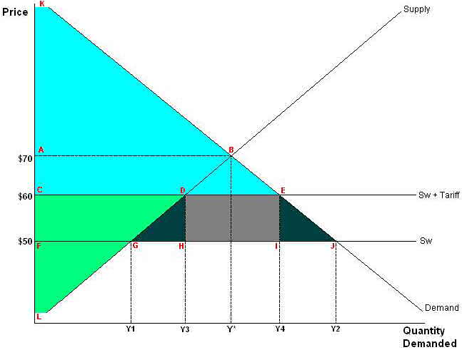 |  | Before tariff  Consumer surplus: AFJ  Producer surplus: FGL  Price: 50  Qty domestic: Y1  Qty foreign: Y2 | After tariff  Consumer surplus: ACE  Producer surplus: CDL  Price: 60  Qty domestic: Y3  Qty foreign: Y4
Consumers unambiguously hurt
(loss of consumer surplus equal to CEFJ)
Domestic producers unambiguously helped
(increase in producer surplus equal to CDFG)
Government collects DEHI
Deadweight loss: DHG and EIJ
Quotas- physical limit on the number or value of goods that can be imported | Subsidies- $ paid by the government to domestic producers
Similar to tariff for consumer and producer surplus, except that benefit is transferred to foreign importers. The higher price is kept by the foreign importers. | better than tariff or quota from perspective of consumer surplus  better than as tariff from perspective of foreigners suppliers  same as tariff from perspective of domestic suppliers  big cost to government that tax payers will eventually have to cover
Other informal barriers  - Licensing requirements  - Product standards  - Domestic buying rules  - Health and safety regulations  - Red tape  - Currency manipulation | Why Do Countries Limit Trade? Legitimate  - Support infant “sunrise” industries  - Avoid overspecialization  - Prevent dumping  - Raise revenue  Nonlegitimate  Protecting declining industries and political favors

International economics  - Two types of economic flows (flow of goods & services and flow of financial assets)  Exports – Imports = NX = Trade balance.  If trade balance > 0, export > import, trade surplus  If trade balance < 0, import > export, trade deficit  If trade balance = 0, export = import, balanced trade | Factors influencing trade balances  - Consumer taste - domestic vs. foreign goods & services  - Prices of goods & services at home and abroad  - The exchange rates used to convert domestic and foreign currency  - Incomes of consumers at home and abroad  - Cost of transporting goods from country to country  - Government policies towards international trade

Flow of financial assets  Financial inflow- flow of financial assets from overseas  Financial outflow- flow of financial assets to overseas  - Two types of financial flows  - Foreign direct investment, e.g. investment in factory overseas  - Portfolio investment, e.g. investment in foreign stocks/bonds  Factors Influencing Capital Flows  - Real interest rates paid on foreign assets  - Real interest rates paid on domestic assets  - Perceived political and economic risks  - Government policies that affect foreign ownership of domestic assets | Trade organizations  MFN- most favored nation  NTR- normal trade relations  EU (European Union)- political, currency, customs union  WTO (World Trade Organization)- investigate violation of trade agreements; meet to form trade agreements  NAFTA (North-American Free Trade Agreement)- Canada, US, Mexico free trade

When a country is running a trade surplus (NX > 0), capital is flowing out of the country (NCO > 0)
When a country is running a trade deficit (NX < 0), capital is flowing into the county (NCO < 0)

A country’s savings is either invested at home or abroad, i.e., SD = ID + NCO, or SD – ID = NCO
If domestic savings is less than domestic investment (SD < ID), then by definition capital will flow into the country (NCO < 0)
If capital flows into the country, the country will run a trade deficit (NX < 0)
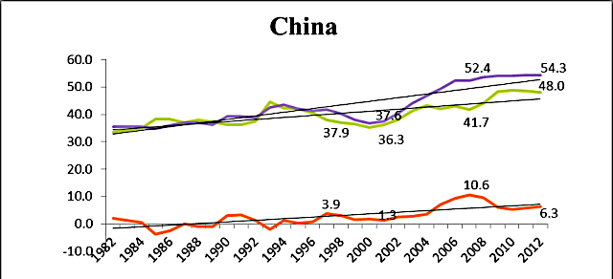 | 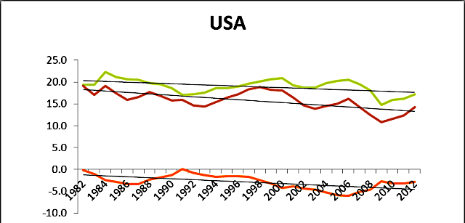
Investment rate high but BELOW savings rate | Investment rate ABOVE savings rate
Capital outflow, surplus (export) | Capital inflow, deficit (import)

Foreign exchange
- Price of one currency vs. another is usually expressed as currency per US$ but not always
- USD is vast majority of one side being traded
- Biggest financial market
- International trade is only a minority, most is just speculation on currency
Fixed (pegged) exchange rates  - System in which a minor currency is fixed to the value of major currency  - Central bank responsible for the minor currency guarantees to buy and sell at the fixed rate  - HKD pegged to USD | Floating exchange rates  - System in which a currency’s value is determined by the market based on supply and demand  - Central bank might move interest rates to influence the value of the currency but doesn’t buy/sell the currency itself  - Yen (dirty float- floating but will intervene at times)
Pros  - Establishes certainty  - Promotes trade and investment between countries  Cons  - Cause country to follow inappropriate monetary policies  - Rarely works over long periods of time | Pros  - Allows each country to run an independent monetary policy  - Simple to operate and not subject to speculative attack  Cons  - Creates business uncertainty and added costs  - As a result, can depress trade/investment
Hybrid Systems
- peg to a basket of currencies rather than one (RMB, Singaporean dollar, etc.)
- allow currency to float but intervene when they think movements are too sudden or speculative

What determines a currency’s value?
Purchasing Power Parity Theory
  - Exchange rates adjust to equilibrate prices in different countries; if a country has high inflation, its currency should fall
  - Big Mac Index- an informal method of measuring purchasing power parity
  - Law of one price should work excluding trade barriers and transportation costs
Mass Psychology Theory- In the short term, currencies are mainly driven by financial flows and speculation

Development- the process by which a nation improves the economic, political, and social well-being of its people
Developed nation- average level of material well-being Less developed nation- low level of material well-being

Human development index (HDI)  - A long and healthy life: Life expectancy at birth  - Education  - A decent standard of living: GNI per capita (PPP US$) | What HDI misses  Environment  Freedom, happiness, stress level, quality of life  Equality
Common characteristics of developing countries
- Low income per capita (PPP), productivity, literacy, expectancy
- Agriculture/extraction industries and dependency on international relations
- High population growth
- Poor market infrastructure (the services and facilities necessary for an economy to function)

1950s: North-South divide; North developed, South undeveloped; the West and the rest, two clear clusters
Now: continuum, no clusters; Africa at the very back

Anti-Aid- not sustainable, taking away their self-initiative, going to fund the corrupted governments’ bureaucracy and military
Pro-Aid- research and development in better farming, AIDS/HIV drugs; lowing infant mortality rate is the new green

