Labor Market Trends

Sec 1=>

Measuring employment and unemployment

- Measurements on unemployment only count people who:
  - Are 16 yrs. or older
  - Actively seeking full time employment
- Does not include people who may be freelancing
- Does not include discouraged workers
- Does not include college students who may want to work part time
- All these are considered “outside” of the labor force
- So, when economy picks up, you sometimes have unemployment increase because people come into the labor force who were outside before

Changes in the labor force

- Shift from agricultural=>heavy =>light manufacturing (electronics) and from product based to services based (insurance, banking, education)

- Entrance of women into the labor force

- Flat world (lower financial and communications barriers) => incr. mobility of labor and capital => entrance of 3rd world poor into global labor force

- Consequence => larger wage gap between educated and uneducated

- Relationship between education and wages/employment
  - Learning effect: education makes you more productive
  - Screening (signaling) effect: if you go through process of getting an education, it signals that you are more dedicated and hard working

- Other changes:
  - more and frequent job changes
  - more freelance and temporary (“contingent”) employment
  - flexible work hours / location of work
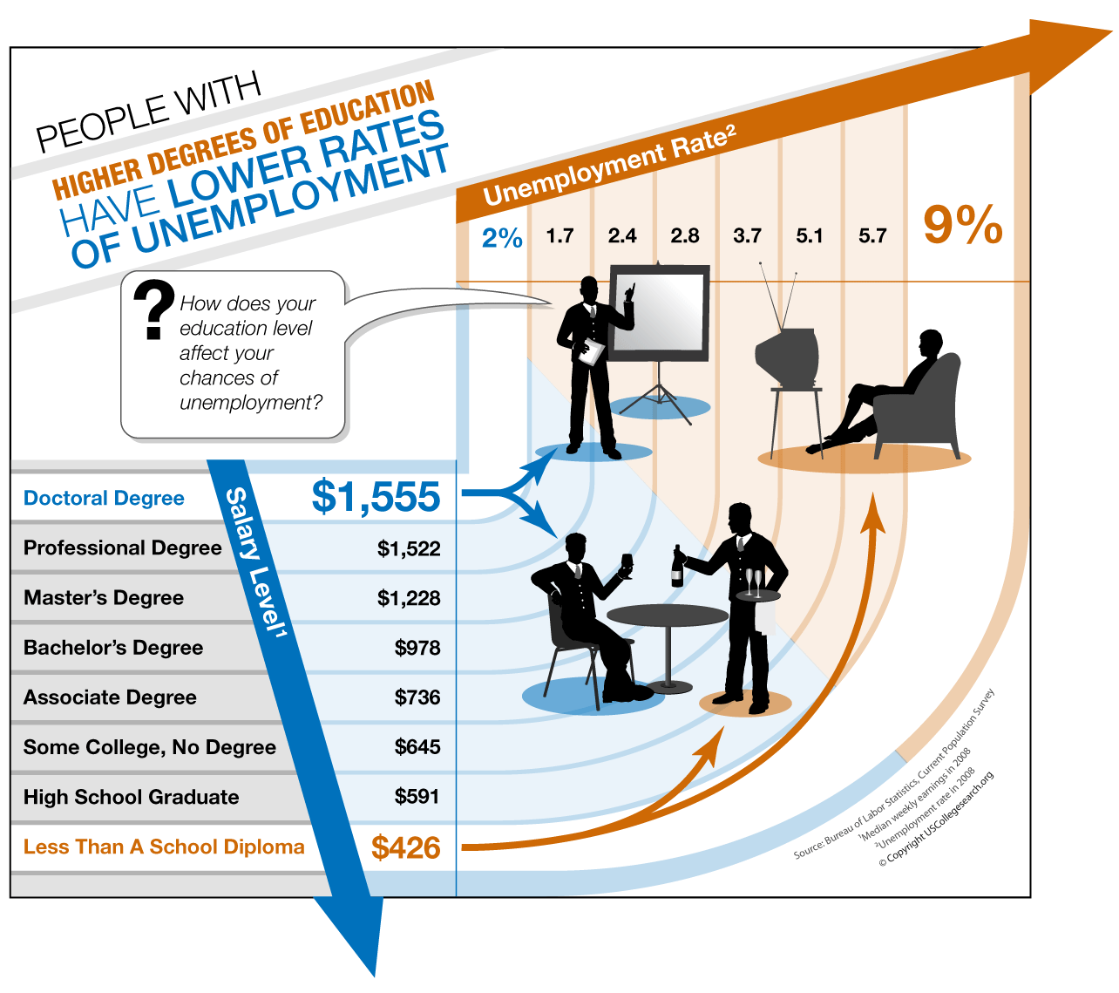
CASE STUDY THE INCREASING VALUE OF SKILLS

Many studies have documented that the earnings gap between workers with high skills and workers with low skills has increased over the past two decades.

In 1978, a man on average earned 66 percent more with a college degree than without one; by 1998, this figure had risen to 118 percent. For woman, the reward for attending college rose from a 55 percent increase in earnings to a 98 percent increase.

Why has the gap in earnings between skilled and unskilled workers risen in recent years?

The first hypothesis is that international trade has altered the relative demand for skilled and unskilled labor. In recent years, the amount of trade with other countries has increased substantially. Imports into the United States have risen from 5 percent of total U.S. production in 1970 to 13 percent in 1998. Exports from the United States have risen from 6 percent in 1970 to 11 percent in 1998. Because unskilled labor is plentiful and cheap in many foreign countries the United States tends to import goods produced with unskilled labor and export goods produced with skilled labor. Thus, when international trade expands, the domestic demand for skilled labor rises, and the domestic demand for unskilled labor falls.

The second hypothesis is that changes in technology have altered the relative demand for skilled and unskilled labor. Consider, for instance, the introduction of computers. Computers raise the demand for skilled workers who can use the new machines and reduce the demand for the unskilled workers whose jobs are replaced by the computers. For example, many companies now rely more on computer databases, and less on filing cabinets, to keep business records. This change raises the demand for computer programmers and reduces the demand for filing clerks. Thus, as more firms begin to use computers, the demand for skilled labor rises, and the demand for unskilled labor falls.

Economists have found it difficult to gauge the validity of these two hypotheses. It is possible, of course, that both are true:
Sec 2=>

SD applied to labor

Why do doctors make more than plumbers? Lawyers more than teachers?

- Demand for labor
  - Concept of “derived demand” (true for all factors of production)
  - Demand for labor tied to demand for product of labor
  - Wages ultimately tied to productivity
  - Wages will match value of labor output (less other input costs)
- Supply of labor follows normal supply dynamics
  - Relatively inelastic in the short term
  - Elastic in the long term (due to time/cost of training)
- Compensating differentials
  - Higher pay for dangerous jobs
  - Lower pay for more enjoyable jobs
  - Summer jobs: beach lifeguard vs. garbage collecting
  - Professor vs. lawyer (same or greater investment in education!)
  - Lower pay for jobs where a few make it big (sports, arts, acting, etc.)
- Discrimination
  - Can it trump profit motive? Are blacks/women paid less because of discrimination of skill differences? If discrimination, couldn’t an all female or all black firm outcompete a white firm?
  - Discrimination by employers or by customers?
  - Discrimination facts:
    - Average pay for women => 30% less than average for men
    - Average pay for blacks => 20% less than average for whites
    - But education/experience levels are different
    - Choice of jobs different for women (desire for more flexibility)?

Interference in the S&D for labor

- Minimum wages = Price floor
  - Theory suggests it should lead to surplus
  - Higher wages for those that can get jobs vs. lower supply of jobs
- Occupational safety laws: decrease in productivity = lower wages? Offset by willingness to take lower pay because work is less hazardous?
  - Information asymmetry situation: employer knows more than employee about the hazards; government rules may be necessary??
- Unions – do they benefit employees in the long term?
- Professional organizations designed to create barriers to entry?

Sec 3=>

Organized labor

- Organized labor = cartel
  - Can shift some consumer surplus to producers (workers)
  - More effective when there are no alternatives for management
  - Over time, jobs will move where labor unions are less powerful
  - Incentives to replace labor with capital
  - Tendency for cheating

- Goal of union movements:
  - Wages
  - Work hours
  - Safety
  - Job security

- Labor organization associated with factory workers in industrial jobs

- Less often associated with professional jobs

- Trends:
  - WWII period: US union membership peaked at 35%
  - Now down to 6% (article)
  - Shows that you can’t hold wages above equilibrium over long term in industries where demand for labor is elastic
  - Union power still high among teachers, government employees and others who can’t easily be replaced with capital or moved overseas

- Why has union membership fallen?
  - Union goals met? (min. wage + health/safety laws?)
  - Change in workforce (less unskilled; more professional work)?
  - Flat world makes it harder to maintain benefits over time

- Terms:
  - Blue and white collar workers
  - Collective bargaining
  - Mediation vs. arbitration
  - Strike or work stoppage

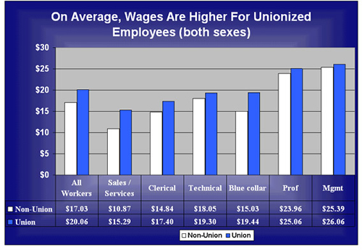

Studies: union workers make 10-20% more than non union workers
Sustainable over time…maybe
But union jobs become fewer and harder to get

