Economics 2nd Test Review

Marginal product of labor is the change in output from hiring on additional unit of labor
Increasing marginal returns- marginal product of labor increases as the number of workers increases
This occurs when there is efficient division of labor (each worker has a role that divides up the total job).
Diminishing marginal returns- marginal product of labor decreases as the number of workers increases
This occurs when workers must work on limited amount of capital (when there is idleness)

Fixed cost is a cost that doesn’t change no matter how much a good is produced
Variable cost is a cost that rises or falls depending on how much is produced
Total cost is the sum of fixed cost and variable cost
Marginal cost is the cost of producing one more unit of a good
Marginal revenue is the additional income from selling one more unit of good.
MC always crosses the lowest point of AVC and ATC. When MC (the cost of producing the next unit) is below the average, it is pulling the average down (thus the curve is decreasing). When MC is above the average, it is pulling the average up (thus the curve is increasing).

Barriers to entry- any factor that makes it difficult for a new firm to enter the market
Startup costs- the expenses a firm must pay before it can begin to produce and sell goods

 | Perfect competition | Monopolistic competition | Oligopoly | Monopoly
Number of firms | Many | Many | A few dominate | One
Variety of goods | None (commodity) | Some | Some | None
Barriers to entry | None | Low | High | Complete
Control over prices | None | Low | Some | Complete
Examples | Wheat, shares of stock | Jeans, books | Cars, movie studios | Public water
 |  | Imperfect competition- doesn’t meet the conditions of perfect competition

Perfect Competition
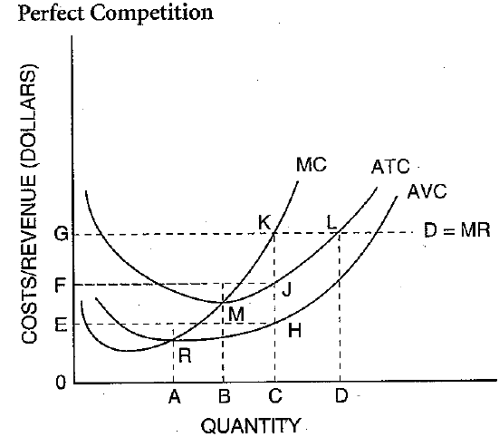 | For a perfect competitive market, demand curve is the marginal revenue curve.  Firms will produce quantity C, where MC is equal to MR, and set the price G.  There is no profit.  Shut down decision (short term)- when the market price is below the AVC, the firms shut down, because for each extra product they sell they are losing money. The more they sell the more they lose.  Exit (long term)- when price is below the lowest point of ATC, the firms will keep operating in the short term, but in the long term the fixed cost isn’t going to decrease, so they will try to reduce their ATC by exiting the market and getting their fixed cost back.
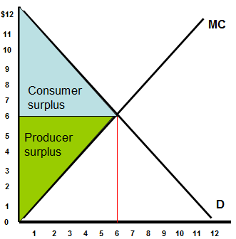

Monopoly
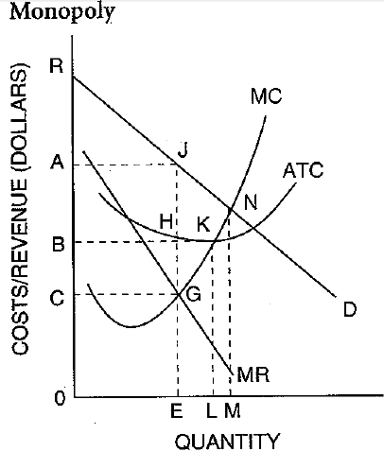 | For a monopoly, demand curve is above the marginal revenue curve.  Firms will produce quantity E, where MC is equal to MR, but set the price A, because that is the price correspondent to the quantity on the demand curve.  The profit is the AJGC because it is the quantity E multiplied by the difference in price A and cost C.  Natural monopoly is a market that runs most efficiently when one large firm supplies all of the output.  Government monopoly is a monopoly created by the government.  Patent- a license that gives the inventor of a new product the exclusive right to sell it for a certain period of time  Franchise- a right to sell a good or service within an exclusive market  License- a government issued right to operate a business
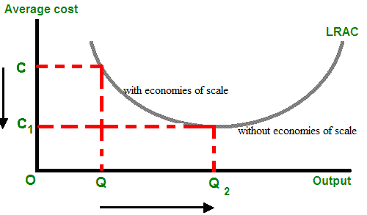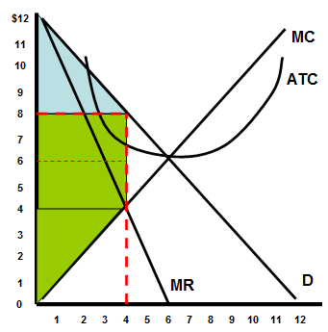
Economies of scale- factors that cause a producer’s average cost per unit to fall as output rises
Price discrimination- division of customers into groups based on how much they will pay for a good
Market power- the ability of a company to change prices and output like a monopolist
- Discounts for different groups of people
- Rebates for people who are willing to provide some free service and information
There has to be
- Some market power- rarely in competitive markets
- Distinct customer group
- Difficult resale
Monopolistic competition and oligopoly
Nonprice competition- a way to attract customers through style, service, or location, but not a lower price
Price war- a series of competitive price cuts that lowers the market price below the cost of production
Collusion- an agreement among firms to divide the markets, set the prices, or limit production
Price fixing- an agreement among firms to change one price for the same good
Cartel- a formal organization of producers that agree to coordinate prices and production

Predatory pricing- selling a product below cost to drive competitors out of the market
Cartel- an illegal grouping of companies that discourages competition
Trust- a group of companies give their shares to a trustee, and the trustee manages all the shares, functioning as a bigger, parent company
Antitrust laws- laws that encourage competition in the marketplace

Merger- combination of two ore more companies into a single firm
Deregulation- the removal of some government controls over a market

Information asymmetry
The sellers know what product is good and what product is bad. The customers don’t know but they know that there is good and bad. Given 50-50 chance, they are only willing to spend half the expected price, which the sellers will not take unless they pick a bad product. So in the end, only bad products are being sold → market failure
To get around it:
- The seller can provide information about their integrity and seriousness in selling good products through expensive advertisement and display.
- The buyer can provide information about their demand so that the sellers are willing to sell to them.

